March 23rd: Don’t Put the Lord Your God to the Test

Hubris – Pride Comes Before a Fall
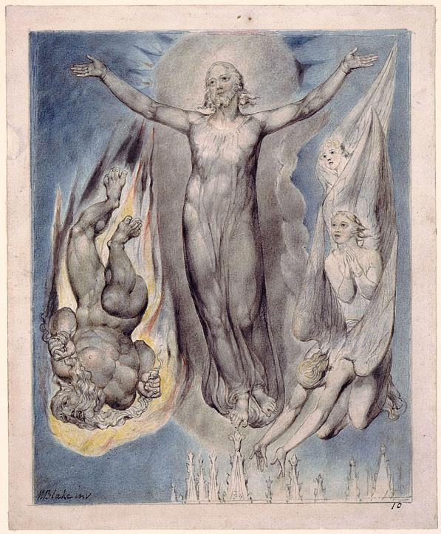

William Blake, "If you are the Son of God, throw yourself down; for it is written, "’He will command his angels concerning you,' and “‘On their hands they will bear you up, lest you strike your foot against a stone.’”

Comments
The second temptation of Christ can be discussed from three aspects:
- The symbolism of the Jerusalem Temple in Jewish culture up to the time of Jesus and the focus on people’s “inner temples” by Christ during His ministry;
- The wisdom of Christ response – uncovering of the conceit of the tempter and implied pride or hubris;
- The representations of hubris in the Old Testament, Greek mythology, and our contemporary lives;

Temple – meaning and symbolism in Jewish tradition and the meaning emphasized by Christ

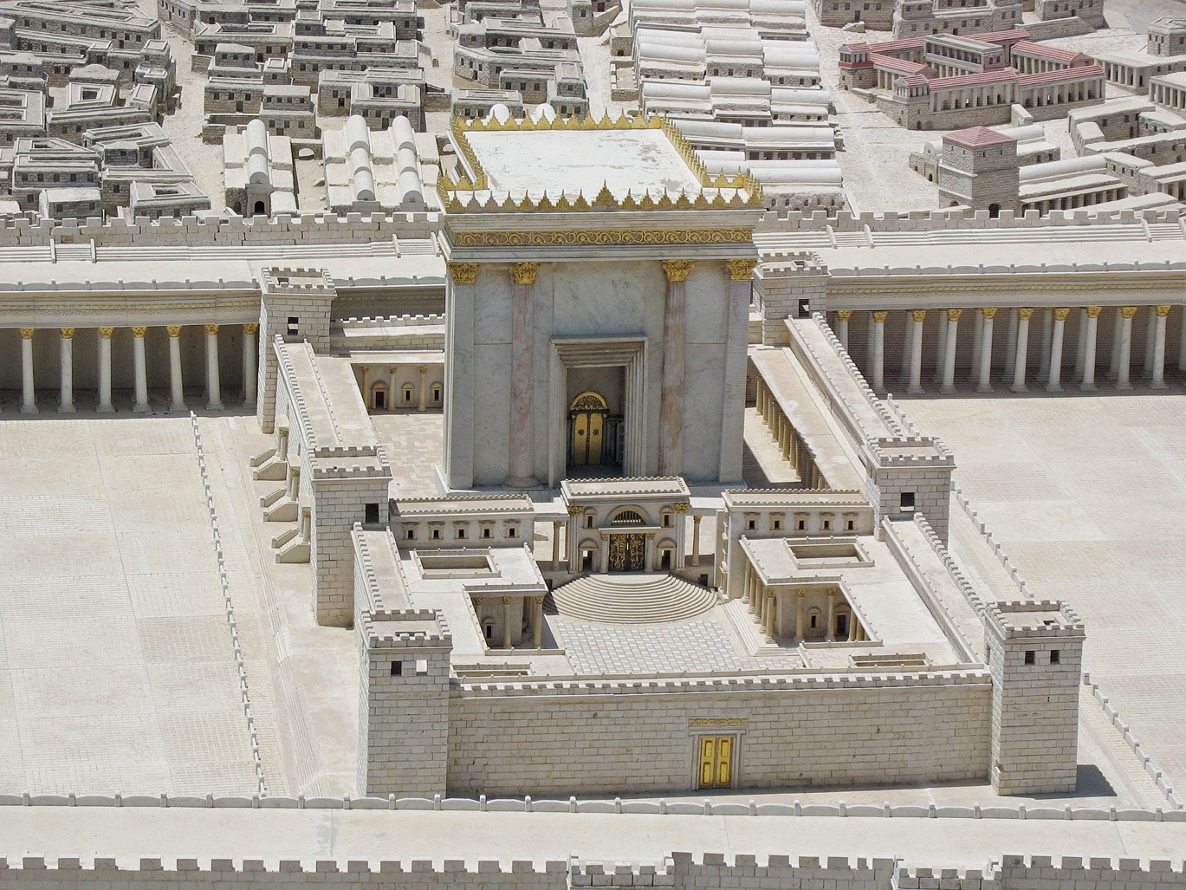
The Model of Herod's Temple at the Holyland Hotel in 1998. Elevated view from the east. Wikipedia

[The Temple in Jerusalem was the most sacred building for the Israelites and Jews. One part of the Temple was the Holy of Holies, the inner sanctuary of the Tabernacle where the Ark of Covenant was kept. The Holy of Holies was viewed as the junction of Heaven and Earth. The Temple was the destination of pilgrimages (during three festivals: Passover, Weeks, and Tabernacles) for religious Jews. The dimensions of the Temple were divinely inspired (as described in two books of the Old Testament the 1 Kings and II Chronicles) and its proportions corresponded to the structure of the universe and human body.For the pious Jews the Temple was the dwelling place of Yahweh.
In many old religious traditions, the human body was represented as a temple built by the Godhead. Christ made a reference to his body when he confronted priests at the Temple: Destroy this temple, and in three days I will raise it up. [Jn 2:19] but throughout His ministry He emphasized the sacredness of the temple in each human being and the role of love in creating that temple. Christ shifted the attention from the external Temple – the outer symbol of humanity’s religious practices, to the temple in our hearts – every individual’s innermost spiritual essence.]

Questions for reflection
Why did the tempter bring Jesus to the pinnacle of the Temple in Jerusalem? What did the Temple mean for Israelis of the time of Jesus? On what grounds could we say that the temptation indicates the misuse of religious power?

What could be the purpose or the lesson of this temptation for us? What authorities in our life do we recognize? Do we put ourselves above the judgment of our legal, financial, academic, etc. authorities?

Why didn’t the tempter offer himself to rescue Jesus during the plunge from the pinnacle? Can we incite others to a “plunge” – to challenge authorities, to risk their life without actually offering them our help?

- The wisdom of Christ’s response – uncovering of the conceit of the tempter and implied pride or hubris
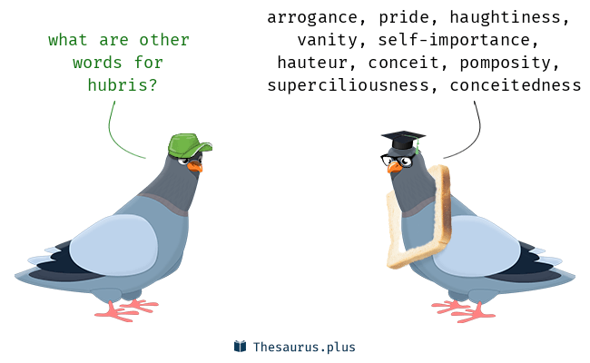
[The word “hubris” appeared in the English language in the late Victorian era. It originates from Greek ὕβρις húbris, where it means insolence, outrage, and presumption towards the gods. Hubris is an exaggerated pride. While pride in itself can be positive (pride of accomplishments or achievements/ pride of our work, etc.), hubris, or exaggerated pride, always refers to an inflated self-image that often involves an expectation that others feel good about us or we feel over-confident.

We could distinguish a wide spectrum of the meaning of hubris from foolishness/ ignorance to hubris.]

Questions for reflection

When does pride of an accomplishment develop into hubris? Did it ever happen to you?

Some individuals defied the seriousness of contracting Covid believing that they cannot be harmed by it or that they feel protected by God. For example, a Czech folk singer Hana Horka and several American preachers/singers deliberately tried to contract Covid or refused to wear masks and get vaccinated. Did they challenge the divine? Could dismissing masks and vaccinations be regarded as challenging experts, scientists, etc. too? How did we develop our own judgment of the lethality of Covid?

Did we experience some sort of wilderness during the most intensive months of the Covid pandemic? What features of that period could be called ‘wilderness”?
How did we respond to: strict control of public spaces; limited gatherings; fear of transmission of the virus; vaccination mandates; testing mandates; masks mandates; anger management or mismanagement; shopping inconveniences; difficulties in seeking medical care; virtual classes; virtual services and meetings; etc.?

Christ was tempted to use His power for His own self-glorification. Consequently, do we feel that we have to serve higher aims of humanity or follow our own desires? Should we place ourselves in the service of the divine Word or our own needs?

- The representations of hubris in the Old Testament, Greek mythology, and our contemporary lives;
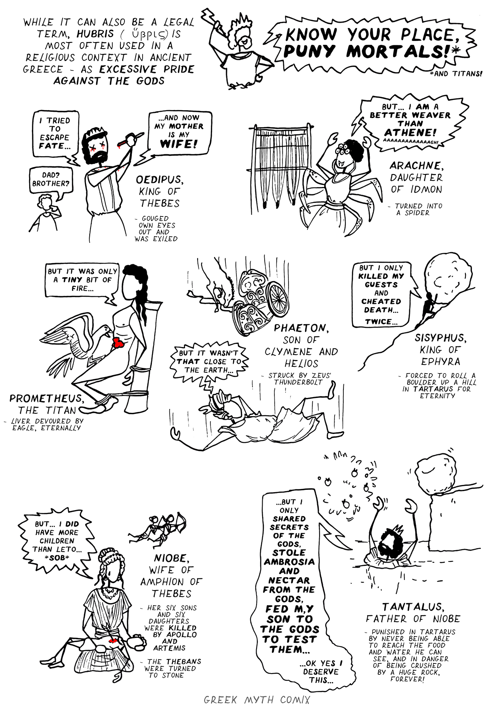
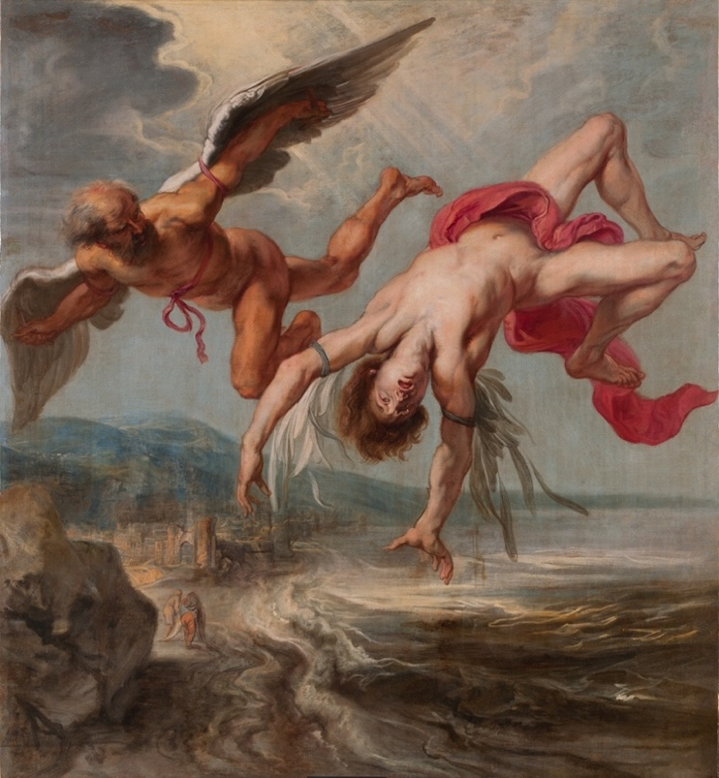
[The Greeks mythology which oral tradition goes back to 18th century BC presents many representations of hubris. In most of the myths, gods punished mortals or other lesser gods for excessive pride or presumptuous acts towards gods.

Icarus fell so in love with his ability to fly that he forgot his father’s warnings and soared high toward the sky, only to lose his wings because the sun melted the wax which kept the feathers together.

Jacob Peter Gowy, The Flight of Icarus (1635-1637)

Niobe boasted that she has more children that the mother of Apollo and Artemis, Leto. In punishment all her twelve children we killed, and she was turned into stone.

[One of the most known examples from the Old Testament is the story of the Tower of Babel.]

Genesis 11: 3-9
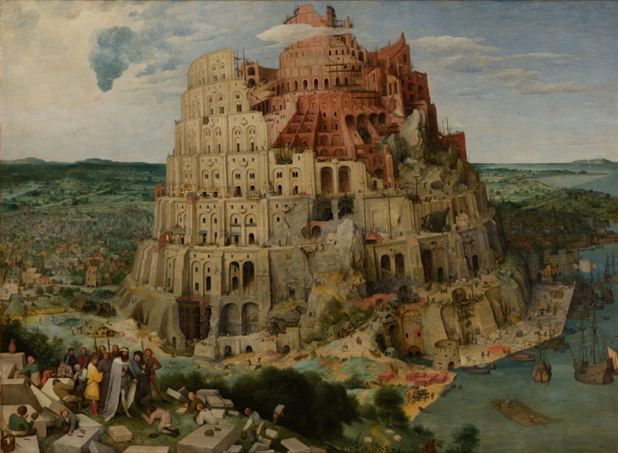
3 They said to each other, “Come, let’s make bricks and bake them thoroughly.” They used brick instead of stone, and tar for mortar. 4 Then they said, “Come, let us build ourselves a city, with a tower that reaches to the heavens, so that we may make a name for ourselves; otherwise we will be scattered over the face of the whole earth.”

Pieter Bruegel the Elder, The Tower of Babel (1563)
⁵ But the Lord came down to see the city and the tower the people were building. ⁶ The Lord said, “If as one people speaking the same language they have begun to do this, then nothing they plan to do will be impossible for them. ⁷ Come, let us go down and confuse their language so they will not understand each other.”
⁸ So the Lord scattered them from there over all the earth, and they stopped building the city. ⁹ That is why it was called Babel^{[c]}—because there the Lord confused the language of the whole world. From there the Lord scattered them over the face of the whole earth.

Questions for reflection

What allows us or leads us to succumb to temptations? How can we develop self-control or temperance to serve higher purposes in our lives?

What is the role of egotism (selfishness) and humility in our lives? Which direction do these two attitudes lead us?

What would happen if everyone in our community would follow his/her own desires disregarding danger or concern for others?

When we count the ‘Likes’ on various apps – are we succumbing to this temptation? Is there a difference between virtual clicks on ‘Like’ or a real hug, warm greeting, invitation for dinner or chit chat in the corridor of an office or a street corner? What is the motivation of young people who strive to be popular and ‘liked’?

How do we distinguish true reality from illusion, imagination, superstition, etc? How to we arrive at truth?

How would you view the difference between foolishness and pride? If an alpinist undertakes a climb on a very challenging mountain (say Mount Everest, McKinley, etc.) without an adequate training and equipment – when would we say that it was foolishness and when it was governed by pride?

Similarly, when could risk-taking be associated with “tempting” the spiritual and divine beings?

Is the challenge to 2022 US election an example of ‘tempting the Lord’? What are the elements of exaggerated pride and where are the elements of justice?

Sources
Valentin Tomberg, Christ and Sophia. Anthroposophic Meditations on the Old, New Testament & Apocalypse, (Great Barrington, MA: SteinerBooks, 2006).
Sergei O. Prokofieff, The Cycle of the Year as a Path of Initiation. Leading to an Experience of the Christ Being. An Esoteric Study of the Festivals, (Forest Row: Temple Lodge, 2014).

Hana Horka: https://www.nytimes.com/2022/01/20/world/hana-horka-covid-czech-singer.html

[Prepared with reverence and humility by Maria L. de Ris]

