Crowning with a Crown of Thorns – Truth Wears the Crown of Thorns

The Origin of Shame and Fear

After Adam and Eve have eaten the forbidden fruit from the Tree of the Knowledge of Good and Evil (which was not necessarily an apple) “the eyes of both were opened, and they knew that they were naked” [Gen 3:7]. Feeling ashamed they made girdles of fig leaves. Soon after a new feeling overtook Adam and Eve – fear. They both hid themselves when they heard God calling them. And Adam responded to God: “I heard the sound of you in the garden, and I was afraid, because I was naked; and I hid myself.”

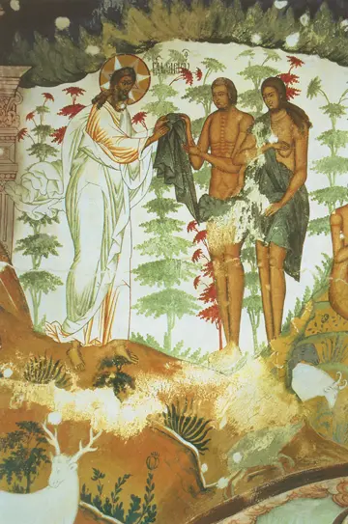
Genesis 3:21-24
21 And the Lord God made garments of skins for the man and for his wife, and clothed them.
22 Then the Lord God said, "See, the man has become like one of us, knowing good and evil; and now, he might reach out his hand and take also from the tree of life, and eat, and live forever"—
23 therefore the Lord God sent him forth from the garden of Eden, to till the ground from which he was taken.
24 He drove out the man; and at the east of the garden of Eden he placed the cherubim, and a sword flaming and turning to guard the way to the tree of life.

Adam and Eve given coat of skins by God, Saint Paul Monastery

In the conduct of Adam and Eve after “their eyes were opened” we can see the role of the feeling of shame (embarrassment) – the feeling that is called an “emotion of self-assessment” or “self-conscious emotion” that was caused by the awakened self-consciousness of Adam and Eve, their separateness from God.

Tracing back shame (embarrassment) and fear to this mythical explanation we also know that both emotions are used as a weapon against individuals, groups, entire populations and even Jesus Christ was exposed to them. Thus, we can ask – what can we learn from Jesus Christ’s voluntarily accepting shaming and mocking? How can shame, an instrument of torture, become our strength?

Questions for reflection
Why did Adam and Eve feel ashamed after they have eaten the forbidden fruit?
When do you think mocking / cynicism/ bulling first appeared in the history of humanity? What circumstances lead to cynical behavior?
How do children respond when caught on doing something bad? Is it easy to recognize that children are ashamed?
Why do you think God gave Adam and Eve a coat to cover their nakedness? What meaning does this gesture have for us? Do you think that the coat was also meant as a protection against the elements of nature?
Could our baptismal white dresses and priestly robes represent the coats God had given to Adam and Eve?
What protection do you need to feel safe in a social environment or in nature?

Deepening of Consciousness – Taking on the World’s Infirmities

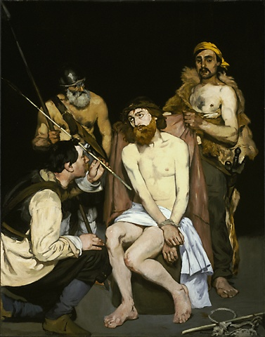
Isaiah 53:3-4
3 He was despised and rejected by others; a man of suffering and acquainted with infirmity; and as one from whom others hide their faces he was despised, and we held him of no account.
4 Surely he has borne our infirmities and carried our diseases; yet we accounted him stricken, struck down by God, and afflicted.

Matthew 16:20-21
20 Then he sternly ordered the disciples not to tell anyone that he was the Messiah.
21 From that time on, Jesus began to show his disciples that he must go to Jerusalem and undergo great suffering at the hands of the elders and chief priests and scribes, and be killed, and on the third day be raised.

Questions for reflection
When do we learn a full and objective value of our deeds?
Could Christ’s disciples understand the necessity of His humiliation in the hands of authorities?

Mocking Jesus and Crowning Him with the Crown of Thorns

A lesson to stand firmly against the vicissitudes

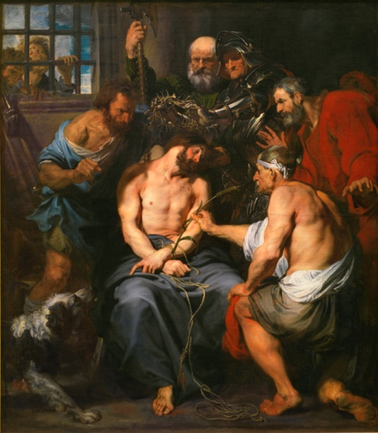
Matthew 20:17-19
17 While Jesus was going up to Jerusalem, he took the twelve disciples aside by themselves, and said to them on the way,
18 "See, we are going up to Jerusalem, and the Son of Man will be handed over to the chief priests and scribes, and they will condemn him to death;
19 then they will hand him over to the Gentiles to be mocked and flogged and crucified; and on the third day he will be raised."

Anthony van Dyck, (1599-1641), Crowning with Thorns, painted ca. 1618-1620

Matthew27:27-31
27 Then the soldiers of the governor took Jesus into the governor's headquarters, and they gathered the whole cohort around him.
28 They stripped him and put a scarlet robe on him,
29 and after twisting some thorns into a crown, they put it on his head. They put a reed in his right hand and knelt before him and mocked him, saying, "Hail, King of the Jews!"
30 They spat on him, and took the reed and struck him on the head.
31 After mocking him, they stripped him of the robe and put his own clothes on him. Then they led him away to crucify him.

Luke 23:10-11, 36-38

10 The chief priests and the scribes stood by, vehemently accusing him.
11 Even Herod with his soldiers treated him with contempt and mocked him; then he put an elegant robe on him, and sent him back to Pilate.
[…]
36 The soldiers also mocked him, coming up and offering him sour wine
37 and saying, "If you are the King of the Jews, save yourself!"
38 There was also an inscription over him, "This is the King of the Jews.

Mark 15:15-20
16 Then the soldiers led him into the courtyard of the palace (that is, the governor's headquarters); and they called together the whole cohort.
17 And they clothed him in a purple cloak; and after twisting some thorns into a crown, they put it on him.
18 And they began saluting him, "Hail, King of the Jews!"
19 They struck his head with a reed, spat upon him, and knelt down in homage to him.
20 After mocking him, they stripped him of the purple cloak and put his own clothes on him. Then they led him out to crucify him.

John 19: 5-6, 9-12
5 So Jesus came out, wearing the crown of thorns and the purple robe. Pilate said to them, "Here is the man!"
6 When the chief priests and the police saw him, they shouted, "Crucify him! Crucify him!" Pilate said to them, "Take him yourselves and crucify him; I find no case against him."
[…]
9 He entered his headquarters again and asked Jesus, "Where are you from?" But Jesus gave him no answer.
10 Pilate therefore said to him, "Do you refuse to speak to me? Do you not know that I have power to release you, and power to crucify you?"
11 Jesus answered him, "You would have no power over me unless it had been given you from above; therefore the one who handed me over to you is guilty of a greater sin."

Questions for reflection
Why did Pilate introduce Jesus by saying “Here is the man” [John 19:5]? What could he mean? Why do you think he didn’t say “Here is your Jesus” or “Here is the King of the Jews”? Do you think that Pilate played into the schemes of the accusers?

Symbolism of clothing
What symbolism do we attach to clothes? What professions follow dress code? Do you think that uniforms (in schools/ working places) are extensions of one’s identity and in many cases their purpose is to evoke respect or at least to bring attention? How do we feel about prison uniforms?
What a crown on somebody’s head symbolizes?

Shame and fear as instruments of punishment and awakening to higher consciousness
Can you remember an event in your life when a humiliation you experienced awakened your conscience and helped you to rise to your higher Self? Did it change your life? Would you say that you actually faced the truth of yourself?
How do we cover shame? When do we avoid showing or feeling shame?
What can we be ashamed of?
Why do we intentionally shame/ bully others (verbally/ in pictures or video, etc.)? (You’re not good in… / It’s embarrassing when you… / body shaming…
How can we draw strength when we are being shamed/ bullied? (“You cannot change how people treat you or what they say about you. All you can do is change how you react to it” Mahatma Gandhi)
What happens when we fear? How do we act, or do we act at all when we are afraid (we say “frozen of fear”)?
How is technology used for shaming people?
Can shaming others have positive results?

Symbolism of the crown of thorns
The crown of thorns that was put on the Christ’s head can be seen as a symbol of the truth that has been rejected, mocked because it was too frightening, too uncomfortable, but the truth that the crown bearer accepted, carried, and sacrificed his or her life for.

Shift of meaning of the concept of shame in the English language:

shame conscience
[embarrassment self-image]

In the English-speaking world, particularly in the US, has been noted an extraordinary shift of meaning of the emotion “shame” – from the Shakespearean shame as a voice of conscience to a modern concern of embarrassment. The shift is from an emotion that could regulate moral conduct to an emotion that is concern with projection of a positive self-image. How can we relate an attitude to truth (such that Jesus Christ represents) from the position of shame and embarrassment? Is there any difference?

Shame is the response of an awakened conscience – a feeling that a person has done something bad and doesn’t want others to know bad things about him or her. This emotion could influence a person’s conduct (avoid bad behavior) and involve and moral considerations.

“Shame! Where is thy blush?” – Hamlet asked his mother disapproving her hastened marriage to his father’s brother. Hamlet most likely hoped that his mother would repent.

Embarrassment indicates concern with one’s own image – it is a projection of the desired image of oneself (“I don’t want people to think about me like this”). The emotion of embarrassment avoids moral judgment of “bad” or “good”, rather its intention is to create a feeling of “self-control” because it is concern with “how other people think about me”. Embarrassment is concerned with “self-presentation in interpersonal interactions”.

Further reflection - examples of overcoming shame and fear
Alone against the world with one’s truth:

Thomas Cranmer, the archbishop of Canterbury, the advisor to King Henry VIII, the author and the compilator of the Book of Common Prayers and the leader of the English Reformation, was accused of heresy by Queen Mary, who wanted to reverse to Catholicism. Although he recanted some of his positions, he was nevertheless sentenced to be burn at the stake in 1556. Just before entering the flames, he renounced his recantations and ashamed wanted his hand to be burned first. His dying words were, "Lord Jesus, receive my spirit. I see the heavens open and Jesus standing at the right hand of God.”

Warsaw Ghetto Uprising – the leaders of the Warsaw Ghetto realizing that the entire population was doomed to death (before April 19, 1943, already a quarter of a million Jews were deported to the extermination camp in Treblinki) organized an uprising standing for the dignity in the face of unavoidable death. The uprising was ultimately crushed, and the ghetto soon turned into a concentration camp.

Galileo Galilei (1564-1642)– stood by his scientific discoveries against the Roman Church; Giordano Bruno (1548-1600) – burnt at the stake for his cosmological beliefs – embracing Copernican model (earth moving around the sun), infinite universe, stars were distant suns surrounded by their own planets;

Not being afraid of shame – awakening conscience in us and others
The image of Jesus Christ crowned with a crown of thorns is a common feature in Polish graveyards and countryside crossroads since the 17th century. The Christ is usually presented in a sitting posture, supporting his head with a right hand, his eyes closed. He has just a few garments on his body. It was imagined that before the Christ was nailed to the cross, He rested at a roadside filled with compassion over humanity. This figure is called the Pensive Christ, but the Polish adjective implies also worried, sorrowful, or saddened, therefore it is also at times translated as the Man of Sorrow. And yet, that image is not the image of the Christ resigned or overburdened. One could say it is the Christ that takes on all the world’s shame, infirmities, and suffering and holds them in his heart.

As Polish history was often filled with tragic outcome for the population, no wonder that common folk identified itself with this figure. Thus, simple wooden carvings of the Pensive Christ have been often placed on the side of graves or tombs or the stature itself formed the head tomb. This sculpture is also, along crosses or statues of Mary, the third most popular shrine placed at the junctures of country roads. Such shrines are rather small and modest, but often surrounded by flowers left there by passersby who pause in their rush to reflect and look at the image of Christ.

What could be a symbol of accepted and transformed shame/ embarrassment in the US?

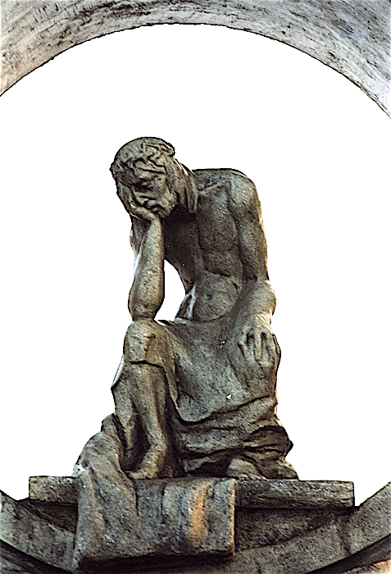
Sculpture of Pensive Christ, graveyard in Roadside shrine, Kurowice, Poland
Zakopane, south Poland

Sources
Valentin Tomberg, Christ and Sophia. Anthroposophic Meditations on the Old, New Testament & Apocalypse, (Great Barrington, MA: SteinerBooks, 2006).
Wierzbicka, Anna, Emotions Across Languages and Cultures: Diversity and Universals. Cambridge University Press: Cambridge, 1999.

[Prepared with reverence by Maria L. de Ris]

