Angels as Messengers and Protectors of God

[In the Christian literature one of the most detailed descriptions of the hierarchies of angels is provided by an ancient philosopher and theologian Pseudo Dionysius the Areopagite (5th – 6th century) in his treatise “The Celestial Hierarchy”. Even now most Christian denominations accept his classification of angels. The following hierarchies are recognized: the highest order - seraphs (seraphim), cherubs (cherubim), thrones; the middle order: dominions, virtues, and powers; the lowest order: principalities, archangels, and angels.

The English word “angel” originates from the Greek ἀγγέλλως aggellos, which in its turn is the translation of the Hebrew מַלְאָכִים‎‎ mal’aḵh, messenger. The Bible presents angels as God’s defenders, protectors, and mediators between God and people. Many passages of the New Testament show that angels recognized and protected Christ during his mission on the earth.]

Hierarchies of Angels

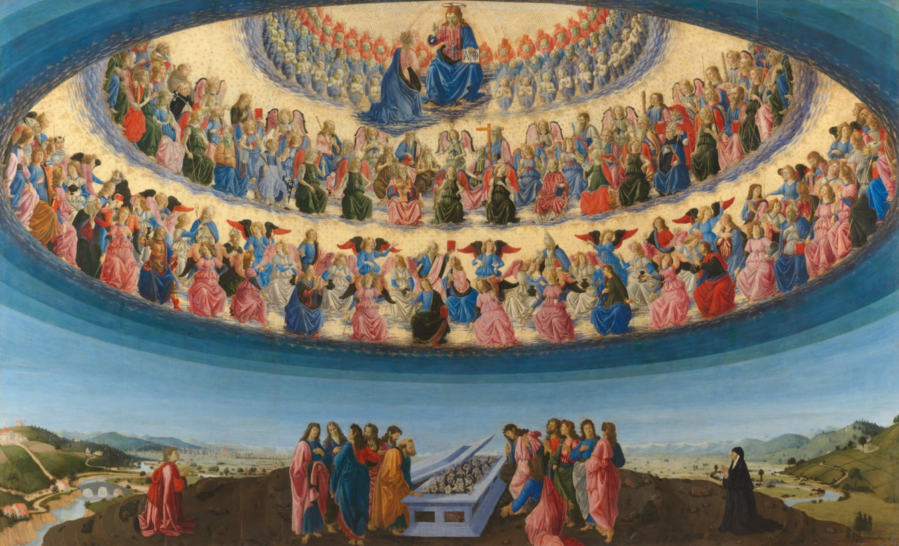
The Assumption of the Virgin – Francesco Botticini

The first hierarchy: Seraphim (Latin seraphim, Hebrew seraphim, spirits of all-love); Cherubim (lat. cherubim, Hebr. cherubim, spirits of the harmonies); Thrones (gr. thronoi, lat. throni, Hebr. aralim, spirits of the will)
The second hierarchy: Kyriotetes (lat. dominationes, Hebr. Tarshishim, dominions, Spirits of Wisdom); Dynamis (lat. virtutes, Hebr. Hashmalim, powers, Spirits of Motion); Exusiai (lat. potestates, Hebrew Elohim, powers, Spirits of Form)
The third hierarchy: Archai (lat. principates, principalities, primal angels, primal powers, spirits of personality); Archangeloi (lat. archangeli, archangels, sons of fire, spirits of fire, arch messengers); Angeloi (lat. angeli, angels, sons of twilight, spirits of twilight, sons of life, messengers)
Cherubim watching the tree of life

Cherub (plural: cherubs, cherubim, or cherubims) are only mentioned in the Old Testament with one exception in Paul’s letter to the Hebrews. Cherubs watched the tree of life in the garden of Eden [Gen 3:24]. The Exodus gives detailed description of two cherubs which were instructed to be placed in the Temple to watch the tabernacle, the Holy of Holies [for instance, Exo 25:18-22]. Cherubs also appeared in the visions of Ezekiel, one of the four major Jewish prophets. The description of “four living creatures” appearing in the Book of Revelation (chapter 4) fits the depiction of cherubs in various parts of the Old Testament.

[After Yahweh discovered that Adam and Eve have eaten the fruit from the forbidden tree, he gave them coats to cover their bodies.]
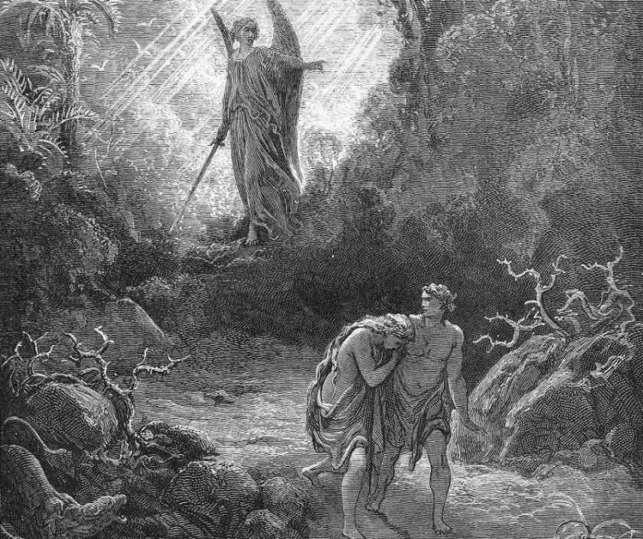
Gustave Dore, Adam and Eve Are Driven out of Eden, 1866

Genesis 3: 22-24
22 Then the Lord God said, "See, the man has become like one of us, knowing good and evil; and now, he might reach out his hand and take also from the tree of life, and eat, and live forever"—
23 therefore the Lord God sent him forth from the garden of Eden, to till the ground from which he was taken.
24 He drove out the man; and at the east of the garden of Eden he placed the cherubim, and a sword flaming and turning to guard the way to the tree of life.

Angel showing John the Evangelist the tree of life

The Book of Revelation 22: 1-5
1 Then the angel showed me the river of the water of life, bright as crystal, flowing from the throne of God and of the Lamb
2 through the middle of the street of the city. On either side of the river is the tree of life with its twelve kinds of fruit, producing its fruit each month; and the leaves of the tree are for the healing of the nations.
3 Nothing accursed will be found there any more. But the throne of God and of the Lamb will be in it, and his servants will worship him;
4 they will see his face, and his name will be on their foreheads.
5 And there will be no more night; they need no light of lamp or sun, for the Lord God will be their light, and they will reign forever and ever.
Questions for reflections
How can we describe the contrast between the role of the angel and cherubs, in the Book of Genesis and in the Book of Revelation?
What meaning could the tree of life in the garden of Eden have? What meaning could it have in the New Heaven where the angel brought John the Evangelist?
Whom does John refer to as a Lamb? What features do we attribute to lamb? Is there a person in our environment we could call a lamb?
How could we connect two figures: Adam and Lamb?
Why, do you think, God gave Eve and Adam a cloak before He sent them out of Eden?

Angels connecting heaven and earth
Jacob’s dream

Genesis 28: 10-14
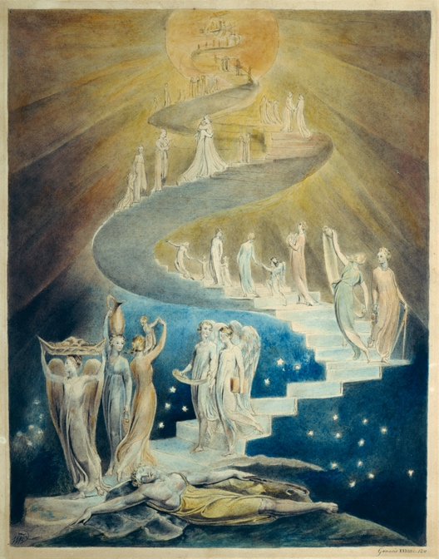
William Blake, Jacob’s Dream (Composed c. 1780-1824)

10 Jacob left Beersheba and went toward Haran.
11 He came to a certain place and stayed there for the night, because the sun had set. Taking one of the stones of the place, he put it under his head and lay down in that place.
12 And he dreamed that there was a ladder set up on the earth, the top of it reaching to heaven; and the angels of God were ascending and descending on it.
13 And the Lord stood beside him and said, "I am the Lord, the God of Abraham your father and the God of Isaac; the land on which you lie I will give to you and to your offspring;
14 and your offspring shall be like the dust of the earth, and you shall spread abroad to the west and to the east and to the north and to the south; and all the families of the earth shall be blessed in you and in your offspring.

John 1: 48-51
48 Nathanael asked him, "Where did you get to know me?" Jesus answered, "I saw you under the fig tree before Philip called you."
49 Nathanael replied, "Rabbi, you are the Son of God! You are the King of Israel!"
50 Jesus answered, "Do you believe because I told you that I saw you under the fig tree? You will see greater things than these."
51 And he said to him, "Very truly, I tell you, you will see heaven opened and the angels of God ascending and descending upon the Son of Man."

Questions for reflections
What connection can we find in Jacob and Jesus Christ? And how these two figures differ?
Who recognized the divinity of Christ? Were there only human beings?
How did Jacob know that it was the God, Yahweh, talking to him?
What does the movement of angels in Jacob’s dream and in the statement of Christ tell us about them?
Are dreams and prophesies coming from the same source? As Christ was not a prophet, how could He know what will happen to Him?

Angels taking on different appearances

Angel of the Lord appearing to Moses in a burning bush

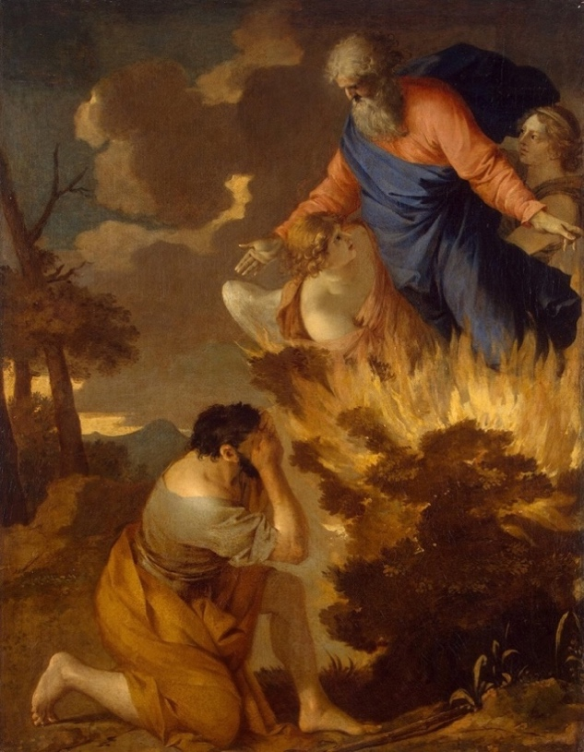
Burning Bush. Seventeenth century painting by Sébastien Bourdon in the Hermitage Museum, Saint Petersburg

Exodus 3:1-6
1 Moses was keeping the flock of his father-in-law Jethro, the priest of Midian; he led his flock beyond the wilderness, and came to Horeb, the mountain of God.
2 There the angel of the Lord appeared to him in a flame of fire out of a bush; he looked, and the bush was blazing, yet it was not consumed.
3 Then Moses said, "I must turn aside and look at this great sight, and see why the bush is not burned up."
4 When the Lord saw that he had turned aside to see, God called to him out of the bush, "Moses, Moses!" And he said, "Here I am."
5 Then he said, "Come no closer! Remove the sandals from your feet, for the place on which you are standing is holy ground."
6 He said further, "I am the God of your father, the God of Abraham, the God of Isaac, and the God of Jacob." And Moses hid his face, for he was afraid to look at God.

Jacob wrestling with the angel
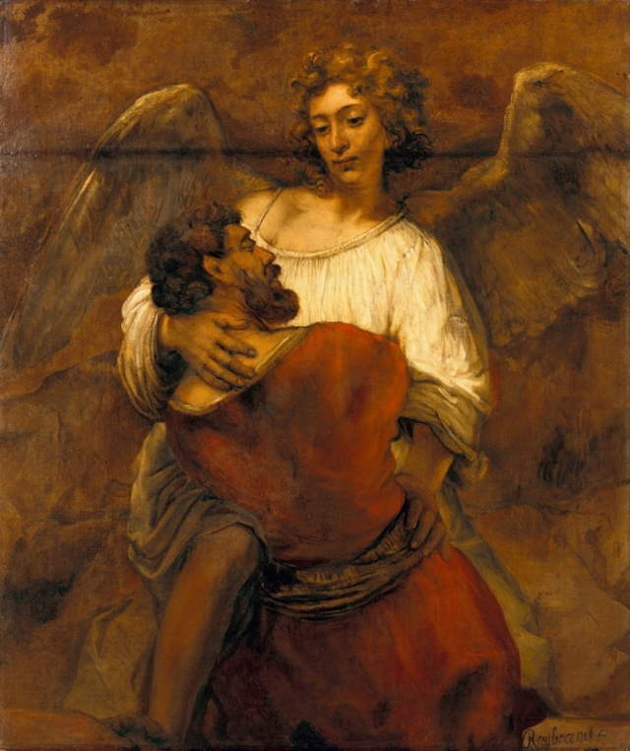
Rembrandt van Rijn Jacob Wrestling with the Angel

Genesis 32: 24-30

24 Jacob was left alone; and a man wrestled with him until daybreak.
25 When the man saw that he did not prevail against Jacob, he struck him on the hip socket; and Jacob's hip was put out of joint as he wrestled with him.
26 Then he said, "Let me go, for the day is breaking." But Jacob said, "I will not let you go, unless you bless me."
27 So he said to him, "What is your name?" And he said, "Jacob."
28 Then the man said, "You shall no longer be called Jacob, but Israel, for you have striven with God and with humans, and have prevailed."
29 Then Jacob asked him, "Please tell me your name." But he said, "Why is it that you ask my name?" And there he blessed him.
30 So Jacob called the place Peniel, saying, "For I have seen God face to face, and yet my life is preserved."

Questions for reflections
How did Jacob know that he was wrestling with God?
How can we be sure that Jacob’s wrestling occurred for real and not in a dream as the time he was dreaming about the angels?
What was the biggest “wrestling” in our lives? When we look back and reflect upon it, does it seem real?
Have we ever awakened from a dream with renewed energy, or with a solution to an important issue we struggled with?
Is there a person in our life who challenged us and thus, made us stronger?

“Holy, Holy, Holy Lord of Hosts”

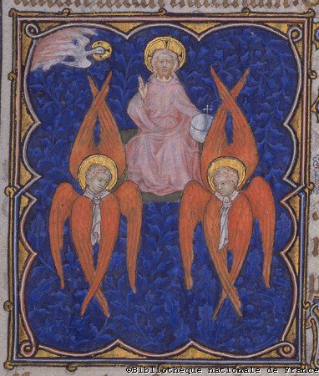
Seraphim surround the divine throne in this illustration from the Petites Heures de Jean de Berry, a 14th-century illuminated manuscript, commissioned by John, Duke of Berry.

Isaiah 6:1-5
1 I saw the Lord sitting on a throne, high and lofty; and the hem of his robe filled the temple.
2 Seraphs were in attendance above him; each had six wings: with two they covered their faces, and with two they covered their feet, and with two they flew.
3 And one called to another and said: "Holy, holy, holy is the Lord of hosts; the whole earth is full of his glory."
4 The pivots on the thresholds shook at the voices of those who called, and the house filled with smoke.
5 And I said: "Woe is me! I am lost, for I am a man of unclean lips, and I live among a people of unclean lips; yet my eyes have seen the King, the Lord of hosts!"
6 Then one of the seraphs flew to me, holding a live coal that had been taken from the altar with a pair of tongs.
7 The seraph touched my mouth with it and said: "Now that this has touched your lips, your guilt has departed and your sin is blotted out."
8 Then I heard the voice of the Lord saying, "Whom shall I send, and who will go for us?" And I said, "Here am I; send me!"

The Book of Revelation 4: 2-11

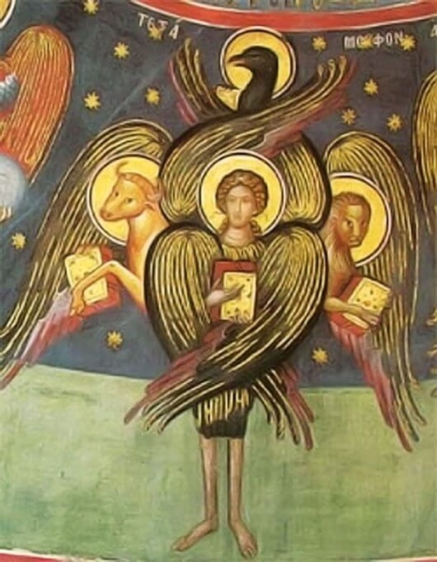
A tetramorph cherub, in Eastern Orthodox iconography

2 At once I was in the spirit, and there in heaven stood a throne, with one seated on the throne!
3 And the one seated there looks like jasper and carnelian, and around the throne is a rainbow that looks like an emerald.
4 Around the throne are twenty-four thrones, and seated on the thrones are twenty-four elders, dressed in white robes, with golden crowns on their heads.
5 Coming from the throne are flashes of lightning, and rumblings and peals of thunder, and in front of the throne burn seven flaming torches, which are the seven spirits of God;
6 and in front of the throne there is something like a sea of glass, like crystal. Around the throne, and on each side of the throne, are four living creatures, full of eyes in front and behind:
7 the first living creature like a lion, the second living creature like an ox, the third living creature with a face like a human face, and the fourth living creature like a flying eagle.
8 And the four living creatures, each of them with six wings, are full of eyes all around and inside. Day and night without ceasing they sing, "Holy, holy, holy, the Lord God the Almighty, who was and is and is to come."
9 And whenever the living creatures give glory and honor and thanks to the one who is seated on the throne, who lives forever and ever,

[Isaiah in his vision saw seraphs surrounding God and glorifying Him. John the Evangelist describes a similar vision – of many six-winged creates unceasingly, day and night, praising God’s glory. Our liturgy preserved the spirit and the wording of the glorification of God and the One who “comes in the name of the Lord”.]

The Great Thanksgiving during the Holy Eucharist (Sanctus)
Therefore we praise you, joining our voices with Angels and Archangels and with all the company of heaven, who for ever sing this hymn to proclaim the glory of your Name:
Holy, Holy, Holy Lord, God of power and might,
heaven and earth are full of your glory.
Hosanna in the highest.
Blessed is he who comes in the name of the Lord.
Hosanna in the highest.

Questions for reflections
Do we feel that “the earth is full of [God’s] glory?
What are our feelings before we take Eucharist? Do we feel thankful to Christ? Do we perceive His presence like the angelic beings did?
How can we glorify God and Christ? How each one of us express our wonderment over the beauty of the world and its mystery?
When did you feel inspired by God, or by Christ, or by any Divine Being? Or by an ordinary person – a man or a woman?

Sources
New Revised Standard Version of the Bible
Pseudo-Dionysius, The Celestial Hierarchy
Wikipedia – cherub, seraph, Jacob Wresting with the Angel, Burning Bush,
AnthroWiki, Hierarchy of Angels

[Prepared with reverence Maria L. de Ris]

