Christ’s Power to Forgive Sins on Earth

Healing of a paralytic
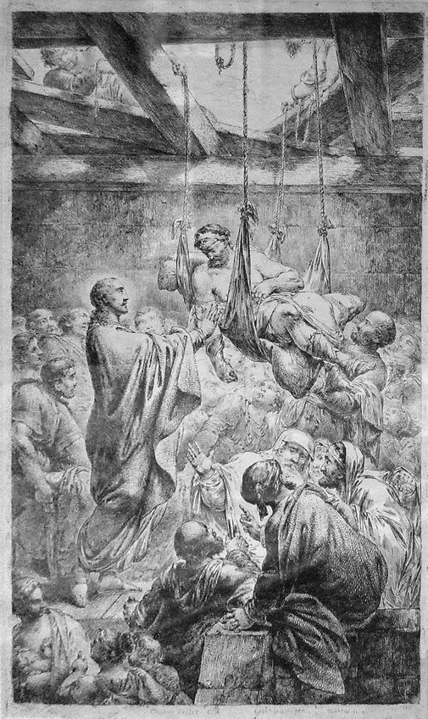

Three synoptical Gospels describe a similar case of the healing of a severely disabled man. The stories differ in small details, but together give a complete image of what happened in that situation. Note how Christ comments on healing and forgiveness.

[The timeframe of the Gospels: the Gospel of Mark probably written around AD 66–70, Matthew and Luke around AD 85–90, and the Gospel of John AD 90–110.]

Christ healing the paralytic at Capernaum by Bernhard Rode 1780.

Mark 2: 5-11
2 So many gathered around that there was no longer room for them, not even in front of the door; and he was speaking the word to them.
3 Then some people came, bringing to him a paralyzed man, carried by four of them.
4 And when they could not bring him to Jesus because of the crowd, they removed the roof above him; and after having dug through it, they let down the mat on which the paralytic lay.
5 When Jesus saw their faith, he said to the paralytic, "Son, your sins are forgiven."
6 Now some of the scribes were sitting there, questioning in their hearts,
7 "Why does this fellow speak in this way? It is blasphemy! Who can forgive sins but God alone?"
8 At once Jesus perceived in his spirit that they were discussing these questions among themselves; and he said to them, "Why do you raise such questions in your hearts?
9 Which is easier, to say to the paralytic, "Your sins are forgiven,' or to say, "Stand up and take your mat and walk'?
10 But so that you may know that the Son of Man has authority on earth to forgive sins"—he said to the paralytic—
11 "I say to you, stand up, take your mat and go to your home."

Matthew 9: 2-6
2 And just then some people were carrying a paralyzed man lying on a bed. When Jesus saw their faith, he said to the paralytic, "Take heart, son; your sins are forgiven."
3 Then some of the scribes said to themselves, "This man is blaspheming."
4 But Jesus, perceiving their thoughts, said, "Why do you think evil in your hearts?
5 For which is easier, to say, "Your sins are forgiven,' or to say, "Stand up and walk'?
6 But so that you may know that the Son of Man has authority on earth to forgive sins"—he then said to the paralytic—"Stand up, take your bed and go to your home."

Luke 5: 18-25
18 Just then some men came, carrying a paralyzed man on a bed. They were trying to bring him in and lay him before Jesus;
19 but finding no way to bring him in because of the crowd, they went up on the roof and let him down with his bed through the tiles into the middle of the crowd in front of Jesus.
20 When he saw their faith, he said, "Friend, your sins are forgiven you."
21 Then the scribes and the Pharisees began to question, "Who is this who is speaking blasphemies? Who can forgive sins but God alone?"
22 When Jesus perceived their questionings, he answered them, "Why do you raise such questions in your hearts?
23 Which is easier, to say, "Your sins are forgiven you,' or to say, "Stand up and walk'?
24 But so that you may know that the Son of Man has authority on earth to forgive sins"—he said to the one who was paralyzed—"I say to you, stand up and take your bed and go to your home."
25 Immediately he stood up before them, took what he had been lying on, and went to his home, glorifying God.

Questions for reflections
How do we understand that ‘the Son of Man has the authority to forgive sins’ committed by us on the earth?
Do we pray to the Christ or to God for forgiveness of our misdeeds or wrongs?
Why is the Christ calling the man whom he just healed ‘friend’ (as in Luke Gospel) or ‘son’ (as in Matthew and Mark Gospels)? What could these words reveal about the relationship of Christ to that man?
What bothered the scribes and the Pharisees more – the act of healing by the Christ or his statement ‘your sins are forgiven’? Do you think they felt threatened by the Christ and his healing abilities? How do we act when we feel threatened by others?
Have we been in a situation that we appealed or acted on behalf of others – for justice, for help, for a better treatment?
How could we relate the act of ‘healing’ and the act of ‘forgiving’ as it was related in these Gospel passages?

Short comments
The Greek manuscript is using two different words for what in English is translated as ‘son’. In the phrase ‘son, your sins are forgiven’ τεκνον’ (teknon), which means child, daughter or son and it’s used as a term showing a more intimate relationship. In the phrase ‘Son of Man’, υιοζ (uihos), which is generally used for male offspring, but in the Greek translation of the Old Testament it’s the term referring to the sons of Abraham, children of Israel or to the awaited Messiah. In the New Testament it’s used by Christ himself whenever He was referring to himself. In Luke Gospel it’s used as a term referring to Adam and born again (sons/ children of resurrection).

Christ forgiving a woman caught in adultery

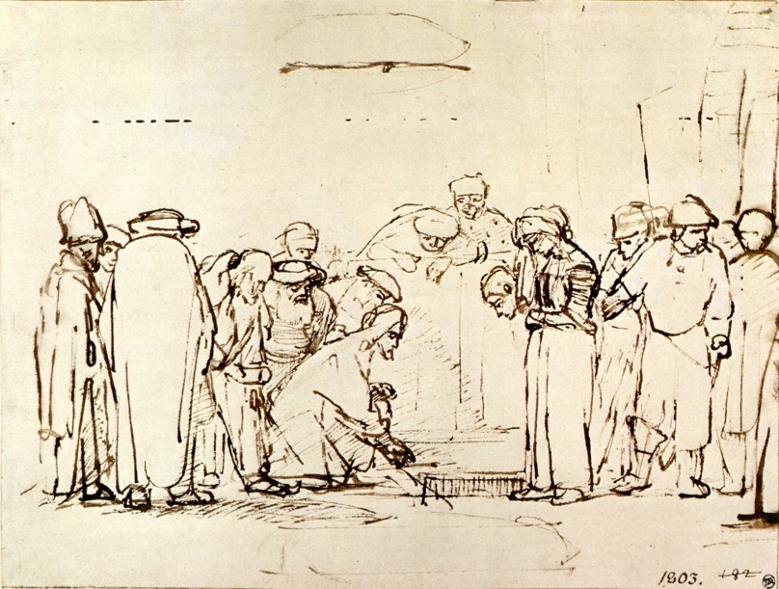

Christ and the woman taken in adultery, drawing by Rembrandt van Rijn (1606 - 1669)

John 8:3-11
3. The scribes and the Pharisees brought a woman who had been caught in adultery; and making her stand before all of them,
4 they said to him, "Teacher, this woman was caught in the very act of committing adultery.
5 Now in the law Moses commanded us to stone such women. Now what do you say?"
6 They said this to test him, so that they might have some charge to bring against him. Jesus bent down and wrote with his finger on the ground.
7 When they kept on questioning him, he straightened up and said to them, "Let anyone among you who is without sin be the first to throw a stone at her."
8 And once again he bent down and wrote on the ground.
9 When they heard it, they went away, one by one, beginning with the elders; and Jesus was left alone with the woman standing before him.
10 Jesus straightened up and said to her, "Woman, where are they? Has no one condemned you?"
11 She said, "No one, sir." And Jesus said, "Neither do I condemn you. Go your way, and from now on do not sin again."

[verse 9 in Modern King James Version:
And hearing, and being convicted by conscience, they went out one by one, beginning at the oldest, until the last. And Jesus was left alone, and the woman standing in the midst.]

The word ‘conscience’ did not appear in the early texts of St. John Gospel, but was brought up by Paul from the Greek language. The Greek word for ‘conscience’ (‘suneidēsis’, moral consciousness) comes from the verb ‘suneidō’, which means: to see in one’s mind, to understand, to be informed

Questions for reflections
Was the women’s wrongdoing forgiven by her accusers?
What was Christ writing on the ground? What did He try to communicate?
How often do we face the dilemma in which Christ was placed in? If Christ let the woman to be stoned, as the Moses law required, he could be accused by the Pharisees and the scribes of violating the law of Roman occupiers which requested that the death sentence had to be approved by the Roman authorities. If he did not condemn the woman to stoning, he’d be accused of violating the Mosaic law. However, Christ found the third solution He appealed to the highest law – each person’s conscience.
Do you think that Christ condemned this woman or has forgiven her?
Do you think that Christ overcame the dualism of thinking (yes or no situation) by using his heart to seek a judgment (or his empathy for the woman)?

What sins are not forgiven?

Luke 12: 8-12
8 "And I tell you, everyone who acknowledges me before others, the Son of Man also will acknowledge before the angels of God;
9 but whoever denies me before others will be denied before the angels of God.
10 And everyone who speaks a word against the Son of Man will be forgiven; but whoever blasphemes against the Holy Spirit will not be forgiven.
11 When they bring you before the synagogues, the rulers, and the authorities, do not worry about how you are to defend yourselves or what you are to say;
12 for the Holy Spirit will teach you at that very hour what you ought to say."

Matthew 12:31-32
31 Therefore I tell you, people will be forgiven for every sin and blasphemy, but blasphemy against the Spirit will not be forgiven.
32 Whoever speaks a word against the Son of Man will be forgiven, but whoever speaks against the Holy Spirit will not be forgiven, either in this age or in the age to come.

Questions for reflections
Why was Christ talking about blasphemy against the Holy Spirit? What was He accused of by the scribes and Pharisees?
What is Holy Spirit? What role in the Trinity does It have?
How did Christ describe to the apostles the acting of the Holy Spirit?
Who was filled with the Holy Spirit?

[On the evening of the resurrection day the Christ appeared to the disciples who were gathered together in a locked room. Mary Magdalene was most likely with the disciples.]

John 21:21-23
21 Jesus said to them again, "Peace be with you. As the Father has sent me, so I send you."
22 When he had said this, he breathed on them and said to them, "Receive the Holy Spirit.
23 If you forgive the sins of any, they are forgiven them; if you retain the sins of any, they are retained."

What other reference can we find about the act of “breathing into somebody” in the Bible?
What did the act of Yahve breathing into Adam meant? Can we compare with it the act of the Christ? What was the role of the Holy Spirit for the apostles?
Should we all feel empowered by Christ to forgive others?

Luke 23: 33-35
33 When they came to the place that is called The Skull, they crucified Jesus there with the criminals, one on his right and one on his left.
34 [Then Jesus said, "Father, forgive them; for they do not know what they are doing."] And they cast lots to divide his clothing.
35 And the people stood by, watching; but the leaders scoffed at him, saying, "He saved others; let him save himself if he is the Messiah of God, his chosen one!"

Are there any other Christ statements which make us more speechless than ‘Father, forgive them; for they do not know what they are doing.’?
How can we attain the power of forgiveness?

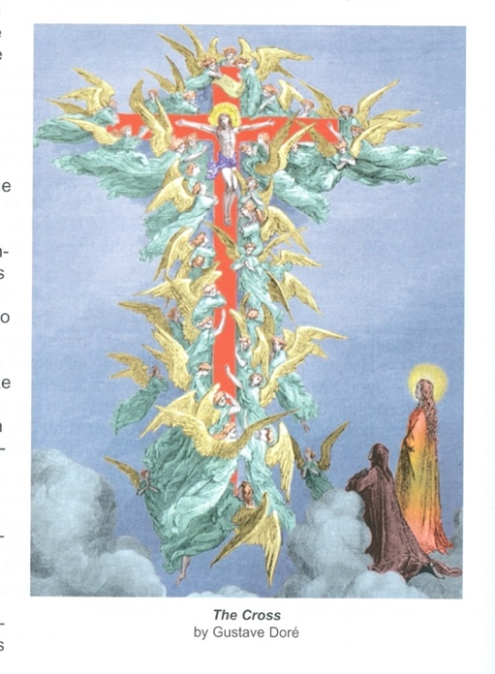
[Prepared by Maria L. de Ris]

