The Lord’s Prayer

Its Relation to the Human Constitution and to Christ’s Temptations

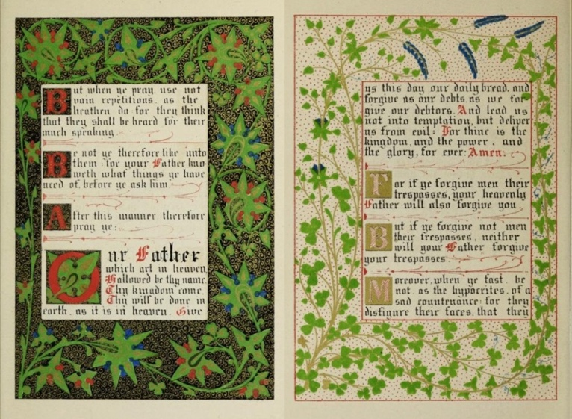
Wikipedia, Lord's Prayer from the 1845 illuminated book of The Sermon on the Mount, designed by Owen Jones

The most common version of the Lord’s Prayer, the one included in Sunday’s liturgy, comes from Matthew Gospel. This prayer is included in a long (stretching for three chapters) sermon that Jesus Christ gave to multitudes, commonly known now as the Sermon on the Mount. Luke Gospel offers another version of the prayer, somewhat shorter, but it indicates that the disciples asked Jesus to teach them how to pray. The last sentence of the prayer, “For thine is the kingdom, and the power, and the glory, for ever and ever.”, is added in many protestant denominations, but not in the Catholic Church where this sentences is part of a doxology said by a priest.

Book of Common Prayer’s version of the Lord’s Prayer

Our Father, who art in heaven,
hallowed be thy Name,
thy kingdom come,
thy will be done,
on earth as it is in heaven.
Give us this day our daily bread.
And forgive us our trespasses,
as we forgive those
who trespass against us.
And lead us not into temptation,
but deliver us from evil.
For thine is the kingdom,
and the power, and the glory,
for ever and ever. Amen.
Matthew 6:7-15

The view of the Mountain of the Beatitudes

7 "When you are praying, do not heap up empty phrases as the Gentiles do; for they think that they will be heard because of their many words.
8 Do not be like them, for your Father knows what you need before you ask him.

9 Our Father in heaven, hallowed be your name.
10 Your kingdom come. Your will be done, on earth as it is in heaven.
11 Give us this day our daily bread.
12 And forgive us our debts, as we also have forgiven our debtors.
13 And do not bring us to the time of trial, but rescue us from the evil one.

14 For if you forgive others their trespasses, your heavenly Father will also forgive you;
15 but if you do not forgive others, neither will your Father forgive your trespasses.

[Luke 11: 1-4
Luke’s version is shorter, it includes five petitions – excluded is “‘your will be done” and “rescue us from the evil one”.
1 He was praying in a certain place, and after he had finished, one of his disciples said to him, "Lord, teach us to pray, as John taught his disciples."
2 He said to them, "When you pray, say: Father, hallowed be your name. Your kingdom come.
3 Give us each day our daily bread.
4 And forgive us our sins, for we ourselves forgive everyone indebted to us. And do not bring us to the time of trial."]

Questions for reflection
Does the fact that the Lord’s Prayer was delivered in the context of Christ’s very long teaching to a multitude of listeners (the teaching is called the Beatitudes: Blessed are the poor in spirit for there is the Kingdom of God, etc.”) changes your attitude to this prayer? Does it make you more aware of the universally human dimension of the prayer?
If Christ taught this prayer to a very narrow number of the disciples, do you think that the prayer had the same recognition as it has now?
Do you feel that “your Father knows what you need before you ask”?

Comment
Note that the Book of Common Prayer is using the word “trespass” while the Matthew Gospel is using “debt” (which is the literal translation of the Greek ὀφείλημα, opheilēma which means something owed, that is (figuratively) a due; morally a fault or debt) and Luke Gospel is using “sin” (which is the most common translation of the Greek ἁμαρτία, hamartia, originating from ἁμαρτάνω, hamartanō, which means not sharing in the prize, missing the mark.
Note also that in the verse 14, the first verse after the end of the text of the Lord’s Prayer, Christ is using anther word for “sin”, namely “trespass” (in Greek παράπτωμα, paraptōma, a side slip (lapse or deviation), that is, (unintentional) error or (wilful) transgression: - fall, fault, offence, sin, trespass.

The first part of the Lord’s Prayer - three petitions, salutations, pertaining to the Father

Our Father who art in heaven
[1] Hallowed be thy Name

[2] Thy kingdom come
[3] Thy will be done on earth as it is in heaven

Questions for reflection
How do you connect Christ’s prayer in Gethsemane, “My Father, if it is possible, let this cup pass from me; yet not what I want but what you want.” with the third petition “thy will be done”?
How does the address “our Father” makes you feel about the character of this prayer? Is it a prayer intended as fulfillment of individual wishes?
When you pray, do you feel that your voice is joining humanity in an appeal to the Father?
How would you feel if you switched the pronoun to “my Father”?

The second part of the Lord’s Prayer –
four petitions pertaining to our constitution
and three temptations of Christ in the wilderness

Just after Jesus was baptized by John the Baptist in the Jordan and became filled with the spirit of Christ, He withdrew into the wilderness where He was tempted. These temptations epitomize three types of trials (temptations), and challenges we face in our lives. These three temptations can be juxtaposed to three petitions included in the Lord’s Prayer. The fourth petition can correspond to Jesus Christ’s Passion – it is an onslaught not only to an aspect of our constitution, but on the essence of our being.

Our physical body – our survival
[4] Give us this day our daily bread

Matthew 4:3-4
3 The tempter came and said to him, "If you are the Son of God, command these stones to become loaves of bread."
4 But he answered, "It is written, "One does not live by bread alone, but by every word that comes from the mouth of God.' "

Questions for reflection
Does this fourth petition refer to physical bread only? What else do we need for survival?
How can we connect this petition with the Eucharistic (Holy Communion) bread? What would be the connection to manna that fed Israelites during their exodus from Egypt?
Can we look at the bread as only the toil of our hands?
[5] Forgive us our debts, as we forgive our debtors
Our connection (debts) to others – parents, friends, community

Matthew 4:8-10
8 Again, the devil took him to a very high mountain and showed him all the kingdoms of the world and their splendor;
9 and he said to him, "All these I will give you, if you will fall down and worship me."
10 Jesus said to him, "Away with you, Satan! for it is written, "Worship the Lord your God, and serve only him.' "

Luke 23:34
"Father, forgive them; for they do not know what they are doing."

Questions for reflection
Do we recognize how much we owe, both in terms of spiritual and material gifts, to our parents, extended families, communities, country?
What important condition is required in the act of forgiveness? Is forgiveness a reciprocal act like giving? Is forgiveness a form of giving?
How do we respond to the contrast between the Satan’s request in the second temptation of Christ and Christ’s admonition: “All who exalt themselves will be humbled, and all who humble themselves will be exalted.” Matthew 23: 12

Our emotions and feelings
[6] Lead us not into temptation

Matthew 4:6-7
6 saying to him, "If you are the Son of God, throw yourself down; for it is written, "He will command his angels concerning you,' and "On their hands they will bear you up, so that you will not dash your foot against a stone.' "
7 Jesus said to him, "Again it is written, "Do not put the Lord your God to the test.' "

Questions for reflection
How do we get mastery of our emotions and desires?
Where there situations in your life that you feel you tempted God? Did you think you were foolish in such situations or proud?
What is the biggest temptation for you? Personal ambition / material wealth / Knowledge?
Where is the line between risk and temptation?

Our ego
[7] Deliver us from evil

Matthew 27: 28-31
28 They stripped him and put a scarlet robe on him,
29 and after twisting some thorns into a crown, they put it on his head. They put a reed in his right hand and knelt before him and mocked him, saying, “Hail, King of the Jews!”
30 They spat on him, and took the reed and struck him on the head.
31 After mocking him, they stripped him of the robe and put his own clothes on him. Then they led him away to crucify him.

Questions for reflection
Have we been in a situation we were deprived of our dignity?
When do we deprive others of their dignity and sanctity?
Have you ever encountered evil? How did you respond to it?
Have you ever felt Schadenfreude? Where is the boundary between Schadenfreude and a just punishment?

Sources
Tomberg, Valentin (2011). Christ and Sophia. Anthroposophic Meditations on the Old Testament, New Testament & Apocalypse. Great Barrington, MA: SteinerBooks.

Prepared with humility by Maria L. de Ris

