Thanksgiving –

Gratitude and Self-Sacrifice as the Ultimate Essence of Christianity

Blessing and Giving Thanks - Christ’s Miraculous Feeding of the Crowds
There are two events of the miraculous feedings of the multitude by Christ. One of them, described by all four Evangelists, is the feeding of a crowd of the five thousand people (“besides women and children”) with only five loaves and two fish. The second event, feeding of the crowd of four thousand men with seven loaves and a few small fishes is only reported in two Gospels, Mark, and Matthew. In the description rendered by all four Evangelists a different Greek word for basket is used, namely κόφινος, kophinos, a small basket, while in the story described only by Mark and Matthew another word for basket is used, namely σπυρίς, spuris, a hamper, basket most likely twice as big as κόφινος.
The miraculous feeding of the crowds can be seen as the initiation of the Eucharist and the example of the transformative power of Christ presence “where two or three are gathered in my name, I am there among them.” [Matthew 18:29]
Feeding of 5,000 Feeding of 4,000
Matt. 14:16-21 Matt 15:32-39
Mark 6:35-44 Mark 8:1-10
Luke 9:12-17
John 6:2-13

Feeding of the Five Thousand

Mark 6:35-44
35 When it grew late, his disciples came to him and said, "This is a deserted place, and the hour is now very late;
36 send them away so that they may go into the surrounding country and villages and buy something for themselves to eat."
37 But he answered them, "You give them something to eat." They said to him, "Are we to go and buy two hundred denarii worth of bread, and give it to them to eat?"
38 And he said to them, "How many loaves have you? Go and see." When they had found out, they said, "Five, and two fish."
39 Then he ordered them to get all the people to sit down in groups on the green grass.
40 So they sat down in groups of hundreds and of fifties.
41 Taking the five loaves and the two fish, he looked up to heaven, and blessed and broke the loaves, and gave them to his disciples to set before the people; and he divided the two fish among them all.
42 And all ate and were filled;
43 and they took up twelve baskets full of broken pieces and of the fish.
44 Those who had eaten the loaves numbered five thousand men.

Matthew 14:16-21
16 Jesus said to them, "They need not go away; you give them something to eat."
17 They replied, "We have nothing here but five loaves and two fish."
18 And he said, "Bring them here to me."
19 Then he ordered the crowds to sit down on the grass. Taking the five loaves and the two fish, he looked up to heaven, and blessed and broke the loaves, and gave them to the disciples, and the disciples gave them to the crowds.
20 And all ate and were filled; and they took up what was left over of the broken pieces, twelve baskets full.
21 And those who ate were about five thousand men, besides women and children.

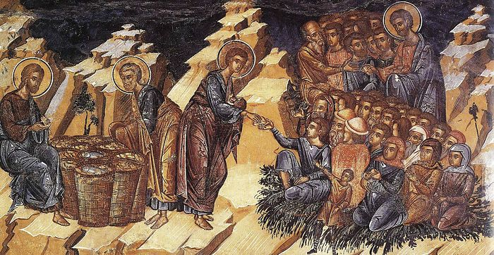
church-viktor.org

Luke 9:12-17
12 The day was drawing to a close, and the twelve came to him and said, "Send the crowd away, so that they may go into the surrounding villages and countryside, to lodge and get provisions; for we are here in a deserted place."
13 But he said to them, "You give them something to eat." They said, "We have no more than five loaves and two fish—unless we are to go and buy food for all these people."
14 For there were about five thousand men. And he said to his disciples, "Make them sit down in groups of about fifty each."
15 They did so and made them all sit down.
16 And taking the five loaves and the two fish, he looked up to heaven, and blessed and broke them, and gave them to the disciples to set before the crowd.
17 And all ate and were filled. What was left over was gathered up, twelve baskets of broken pieces.

John 6:2-13
2 A large crowd kept following him, because they saw the signs that he was doing for the sick.
3 Jesus went up the mountain and sat down there with his disciples.
4 Now the Passover, the festival of the Jews, was near.
5 When he looked up and saw a large crowd coming toward him, Jesus said to Philip, "Where are we to buy bread for these people to eat?"
6 He said this to test him, for he himself knew what he was going to do.
7 Philip answered him, "Six months' wages would not buy enough bread for each of them to get a little."
8 One of his disciples, Andrew, Simon Peter's brother, said to him,
9 "There is a boy here who has five barley loaves and two fish. But what are they among so many people?"
10 Jesus said, "Make the people sit down." Now there was a great deal of grass in the place; so they sat down, about five thousand in all.
11 Then Jesus took the loaves, and when he had given thanks, he distributed them to those who were seated; so also the fish, as much as they wanted.
12 When they were satisfied, he told his disciples, "Gather up the fragments left over, so that nothing may be lost."
13 So they gathered them up, and from the fragments of the five barley loaves, left by those who had eaten, they filled twelve baskets.

Questions for reflection
How do you view the evolution of consciousness and the value of human beings from times when gods required sacrifices from people, including human sacrifice to the coming of Christ, the Divinity, who himself thanked His Father for granting Him the power to multiply the food for the crowds?
[One of the most dramatic examples of human sacrifice is the story of the Greek king Agamemnon who had to agree to offer his own daughter Iphigenia to gods to plea for propitious winds so that he could sail to Troy. Another well-known example of attempted human sacrifice is the trail of Abraham to sacrifice his only son, Isaac, as a proof of his faithfulness to Yahve. That sacrifice was providentially stopped.),
What example is Christ giving us by blessing of the bread and fish and giving thanks to God? How do we bless the food we eat? How do we express gratitude?
What is food for us? Do we recognize the spiritual aspect of food too?
What is the meaning of eating together with others – family and/ or friends and eating alone? Do you like to share your food with others?
How can we relate Christ’s giving thanks to God and older forms of sacrifice to gods (or Yahve) to plead for blessings?

Establishment of Eucharist

[The words Jesus Christ said to the apostles during the Last Supper are found in all synoptical Gospels, Matthew, Mark, and Luke]
The Greek word for “to give thanks, to express gratitude, to say grace at a meal” is εὐχαριστέω, eucharisteō and the Greek word for “to bless, to praise, to invoke a benedction” is εὐλογέω, eulogeō. We thus can infer that Eucharist means Thanksgiving. Jesus Christ followed the Jewish customs of blessing the food.

The Last Supper
Luke 22: 17-20
Then he took a cup, and after giving thanks he said, "Take this and divide it among yourselves;
for I tell you that from now on I will not drink of the fruit of the vine until the kingdom of God comes."
Then he took a loaf of bread, and when he had given thanks, he broke it and gave it to them, saying, "This is my body, which is given for you. Do this in remembrance of me."
And he did the same with the cup after supper, saying, "This cup that is poured out for you is the new covenant in my blood.

Matthew 26:26-28
While they were eating, Jesus took a loaf of bread, and after blessing it he broke it, gave it to the disciples, and said, "Take, eat; this is my body."
Then he took a cup, and after giving thanks he gave it to them, saying, "Drink from it, all of you;
for this is my blood of the covenant, which is poured out for many for the forgiveness of sins.

Mark 14:22-24
While they were eating, he took a loaf of bread, and after blessing it he broke it, gave it to them, and said, "Take; this is my body."
Then he took a cup, and after giving thanks he gave it to them, and all of them drank from it.
He said to them, "This is my blood of the covenant, which is poured out for many.

The Holy Communion; Eucharistic Prayer (Book of Common Prayer), Prayer C
Agnus Dei, Jan v. Eyck, Gent Altar 1432

Celebrant The Lord be with you.
People And also with you [your spirit].
Celebrant Lift up your hearts.
We lift them to the Lord.
Celebrant Let us give thanks to the Lord our God.
People It is right to give him thanks and praise.”

****

“For on the night that he was betrayed, our Lord Jesus Christ took bread; and when he had given thanks, he broke it,* and gave it to his disciples, saying, “Take, eat; this is my Body, which is given for you: Do this in remembrance of me.”

[Before the Ministration of Communion]
“The gifts of God for the people of God. Take them in remembrance that Christ died for you and lives for you, and feed on him in your hearts by faith, with thanksgiving.”
Questions for reflection
What are your feelings when you approach the altar and take the Eucharist (wafer)?
How is Christ’s self-sacrifice expressed in the three Gospel readings?
What does the transition from sacrificial offerings to God to self-sacrifice mean to you?
What is the meaning of breaking the bread (“after blessing [a loaf of bread] he broke it, gave it to them…”)? Why do you think it is an important act? Note that all three synoptical Gospels include the phrase “broke” but John says “distributed”.
When receiving the bread (and wine) becomes the most transformative experience for you? How do you feel union with Christ?
How do you feel the presence of Christ during the Communion?
Cynthia Bourgeault, an Episcopal minister and mistic, suggested to interpret the word “remembrance [re-member = putting all members together]” as a “living presence”. Do you feel Christ presence when you take a Eucharist?
Do we recognize Jesus Christ as the Sacrificial Lamb for all of us, for all mankind?

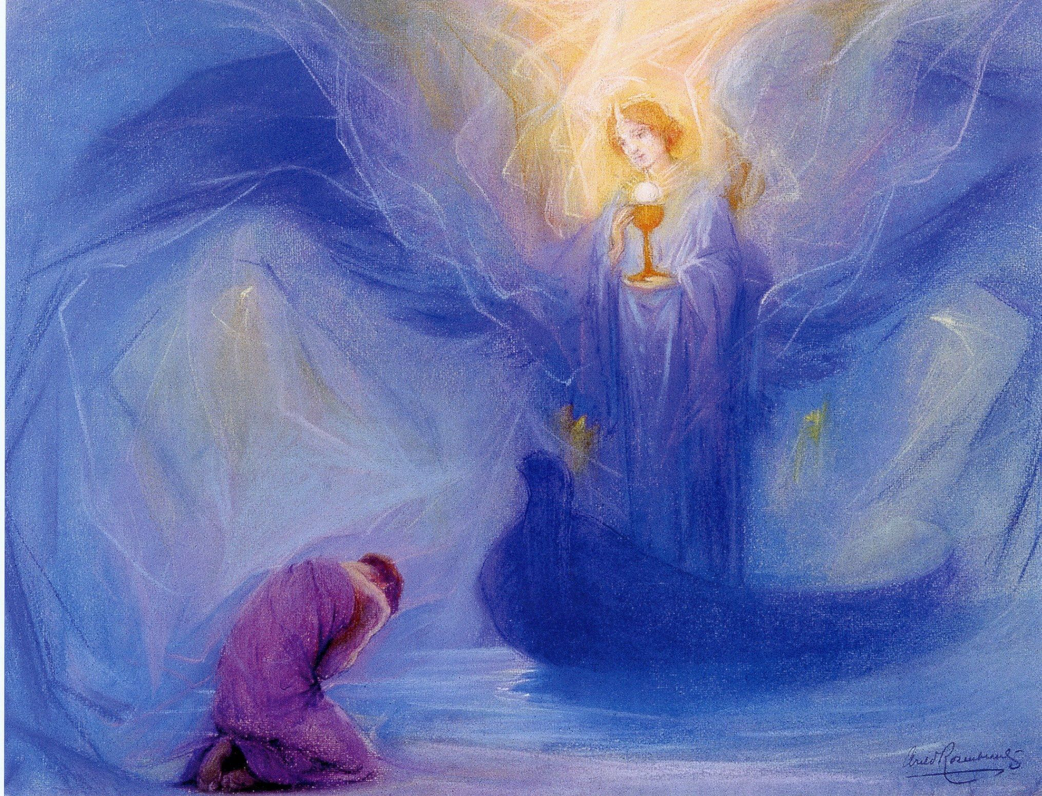
Arild Rozenkrantz, Angel

Resources
1979 edition of the Book of Common Prayer
http://justus.anglican.org/resources/bcp/bcp.htm
Cynthia Bourgeault, 2008,The Wisdom of Jesus. Transforming Heart and Mind – A New Perspective on Christ and His Message, Shambala.

Prepared with reverence by Maria L. de Ris

