Part II - The Divine Consolation: Be Not Afraid!

Transfiguration of Christ
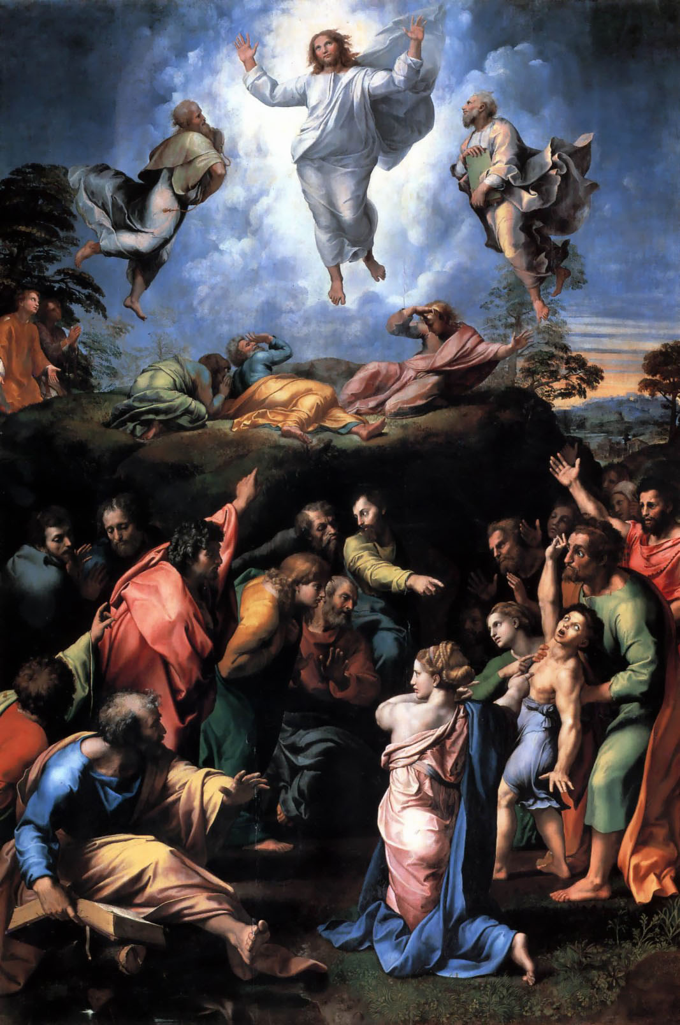
[Three apostles: Peter, and two brothers James and John, witnessed a glorification of Jesus Christ and the appearance of Elijah and Moses standing around Jesus. Then a voice from the clouds was heard “This is my Son, the Beloved, listen to Him!”]

Mark 9: 2-10
2 Six days later, Jesus took with him Peter and James and John, and led them up a high mountain apart, by themselves. And he was transfigured before them,
3 and his clothes became dazzling white, such as no one on earth could bleach them.
4 And there appeared to them Elijah with Moses, who were talking with Jesus.
5 Then Peter said to Jesus, "Rabbi, it is good for us to be here; let us make three dwellings, one for you, one for Moses, and one for Elijah."
6 He did not know what to say, for they were terrified.
7 Then a cloud overshadowed them, and from the cloud there came a voice, "This is my Son, the Beloved; listen to him!"
8 Suddenly when they looked around, they saw no one with them any more, but only Jesus.
9 As they were coming down the mountain, he ordered them to tell no one about what they had seen, until after the Son of Man had risen from the dead.
10 So they kept the matter to themselves, questioning what this rising from the dead could mean.

Matthew 17:1-9
1 Six days later, Jesus took with him Peter and James and his brother John and led them up a high mountain, by themselves.
2 And he was transfigured before them, and his face shone like the sun, and his clothes became dazzling white.
3 Suddenly there appeared to them Moses and Elijah, talking with him.
4 Then Peter said to Jesus, "Lord, it is good for us to be here; if you wish, I will make three dwellings here, one for you, one for Moses, and one for Elijah."
5 While he was still speaking, suddenly a bright cloud overshadowed them, and from the cloud a voice said, "This is my Son, the Beloved; with him I am well pleased; listen to him!"
6 When the disciples heard this, they fell to the ground and were overcome by fear.
7 But Jesus came and touched them, saying, "Get up and do not be afraid."
8 And when they looked up, they saw no one except Jesus himself alone.
9 As they were coming down the mountain, Jesus ordered them, "Tell no one about the vision until after the Son of Man has been raised from the dead."

Luke 9:28-36
28 Now about eight days after these sayings Jesus took with him Peter and John and James and went up on the mountain to pray.
29 And while he was praying, the appearance of his face changed, and his clothes became dazzling white.
30 Suddenly they saw two men, Moses and Elijah, talking to him.
31 They appeared in glory and were speaking of his departure, which he was about to accomplish at Jerusalem.
32 Now Peter and his companions were weighed down with sleep; but since they had stayed awake, they saw his glory and the two men who stood with him.
33 Just as they were leaving him, Peter said to Jesus, "Master, it is good for us to be here; let us make three dwellings, one for you, one for Moses, and one for Elijah"—not knowing what he said.
34 While he was saying this, a cloud came and overshadowed them; and they were terrified as they entered the cloud.
35 Then from the cloud came a voice that said, "This is my Son, my Chosen; listen to him!"
36 When the voice had spoken, Jesus was found alone. And they kept silent and in those days told no one any of the things they had seen.

Questions for reflections
How can we connect the voice of Yahve which Adam and Eve and Job heard and the voice from the cloud proclaiming Jesus Christ as His Son? How does their message differ?
Are there similarities of the feeling of fear which overtook Adam and Eve and the three apostles?
What effect had the manifestation of Yahve’s majesty on Job and the glorification of the Christ by the Father on the apostles?
How can we interpret the relationship of the Christ to the apostles after His transfiguration?
What could be the lasting effect of the vision of the transfiguration of the Christ on the apostles?
How did the attitude to the Divine Being change over time – from the time of Adam and Eve, Job, the Apostles and now? How did the fear of God change?
Why did the Christ choose only three apostles to the home of the leader of the synagogue?
Are we able to overcome fear with faith? Do you have any memories of overcoming fear with faith or hope?
Do you think that even the Christ felt fear? When could it have happened?
Do you think that the great leaders of mankind were free of the feeling of fear? Or soldiers on the battlefields or during any dangerous operations are free of fear?
Does prayer help you to overcome fear?

Christ as the One who can heal fears

Jesus Walking on the Sea
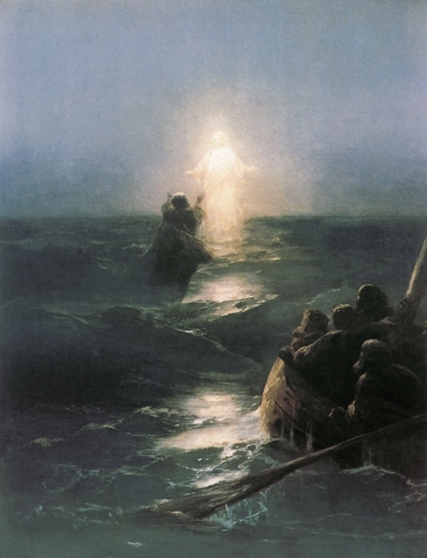

Three Gospels, the Gospel of Mark, Matthew, and John, describe similar situation of Jesus Christ walking on the sea. They differ only in very minor details, except that the story of Peter’s attempt to reach Christ by walking on the sea is only presented in the Matthew Gospel.

All three passages relate about an aspect of fear – a fear of something unusual, unexplainable, extraordinary, or awesome.

Ivan Ayyazovsky 1888 Walking on Sea Public Domain,

Matthew 14:25-33
25 And early in the morning he came walking toward them on the sea.
26 But when the disciples saw him walking on the sea, they were terrified, saying, "It is a ghost!" And they cried out in fear.
27 But immediately Jesus spoke to them and said, "Take heart, it is I; do not be afraid."
28 Peter answered him, "Lord, if it is you, command me to come to you on the water."
29 He said, "Come." So Peter got out of the boat, started walking on the water, and came toward Jesus.
30 But when he noticed the strong wind, he became frightened, and beginning to sink, he cried out, "Lord, save me!"
31 Jesus immediately reached out his hand and caught him, saying to him, "You of little faith, why did you doubt?"
32 When they got into the boat, the wind ceased.
33 And those in the boat worshiped him, saying, "Truly you are the Son of God."

Mark 6:45-52
When evening came, the boat was out on the sea, and he was alone on the land.
48 When he saw that they were straining at the oars against an adverse wind, he came towards them early in the morning, walking on the sea. He intended to pass them by.
49 But when they saw him walking on the sea, they thought it was a ghost and cried out;
50 for they all saw him and were terrified. But immediately he spoke to them and said, "Take heart, it is I; do not be afraid."
51 then he got into the boat with them and the wind ceased. And they were utterly astounded,

John 6: 15-21
15 When Jesus realized that they were about to come and take him by force to make him king, he withdrew again to the mountain by himself.
16 When evening came, his disciples went down to the sea,
17 got into a boat, and started across the sea to Capernaum. It was now dark, and Jesus had not yet come to them.
18 The sea became rough because a strong wind was blowing.
19 When they had rowed about three or four miles, they saw Jesus walking on the sea and coming near the boat, and they were terrified.
20 But he said to them, "It is I; do not be afraid."
21 Then they wanted to take him into the boat, and immediately the boat reached the land toward which they were going.

Questions for reflections
Why do you think the disciples become afraid when they saw Jesus Christ walking on the sea? Do you think that they displayed the fear of God similar to how Adam and Eve responded?
Do we always respond with fear or shock when something extraordinary or unusual happens? Do you remember how you responded to the plane crash into the Twin Towers? Was that the same fear as the disciples could have felt?
Do you think that Peter was ‘fearless’ when he jumped into the water and started to walk on the sea? Do you think that, as Matthew indicates that the strong winds caused fear in Peter? Could we assume that he got frightened by his own ability to walk on the sea?
What happens when we start doubting our abilities?
How do we feel when we doubt in God’s protection?
What effect have Christ’s words ‘Do not be afraid’ on us?

Quieting the Storm

Fear as response to the overwhelming powers of nature
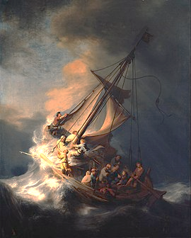

Rembrandt
The Storm on the Sea of Galilee is a 1633 oil-on-canvas painting by the Dutch Golden Age painter Rembrandt van Rijn. It was previously in the Isabella Stewart Gardner Museum in Boston but was stolen in 1990 and remains missing.

Luke 8: 22-25
22 They went to him and woke him up, shouting, "Master, Master, we are perishing!" And he woke up and rebuked the wind and the raging waves; they ceased, and there was a calm.
25 He said to them, "Where is your faith?" They were afraid and amazed, and said to one another, "Who then is this, that he commands even the winds and the water, and they obey him?"

Matthew 8:23-27
23 And when he got into the boat, his disciples followed him.
24 A windstorm arose on the sea, so great that the boat was being swamped by the waves; but he was asleep.
25 And they went and woke him up, saying, "Lord, save us! We are perishing!"
26 And he said to them, "Why are you afraid, you of little faith?" Then he got up and rebuked the winds and the sea; and there was a dead calm.
27 They were amazed, saying, "What sort of man is this, that even the winds and the sea obey him?"

Mark 4:36-41
36 And leaving the crowd behind, they took him with them in the boat, just as he was. Other boats were with him.
37 A great windstorm arose, and the waves beat into the boat, so that the boat was already being swamped.
38 But he was in the stern, asleep on the cushion; and they woke him up and said to him, "Teacher, do you not care that we are perishing?"
39 He woke up and rebuked the wind, and said to the sea, "Peace! Be still!" Then the wind ceased, and there was a dead calm.
40 He said to them, "Why are you afraid? Have you still no faith?"
41 And they were filled with great awe and said to one another, "Who then is this, that even the wind and the sea obey him?"

Questions for reflections
Should the apostles have shown faith in their abilities or in Christ?
Do we have examples when our faith overcame our fears?
How do we seek help when we are afraid?
Does nature’s power fill us with trembling?
Did we feel afraid during the first months of COVID-19? How did we overcome it?

