The Origin of Fear and How Can We Work with It

Hiding out of shame and fear of God vs. reaching out to Christ

Fear of God vs. Consolation of the Healing

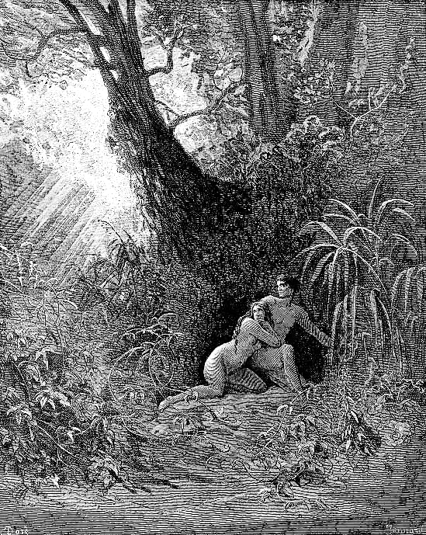
Gustave Dore - Illustration to Paradise Lost by John

Genesis 3:8-10

[4 But the serpent said to the woman, "You will not die;
5 for God knows that when you eat of it your eyes will be opened, and you will be like God, knowing good and evil."
6 So when the woman saw that the tree was good for food, and that it was a delight to the eyes, and that the tree was to be desired to make one wise, she took of its fruit and ate; and she also gave some to her husband, who was with her, and he ate.
7 Then the eyes of both were opened, and they knew that they were naked; and they sewed fig leaves together and made loincloths for themselves.]
8 They heard the sound of the Lord God [Yehovah Elohim] walking in the garden at the time of the evening breeze, and the man and his wife hid themselves from the presence of the Lord God among the trees of the garden.
9 But the Lord God called to the man, and said to him, "Where are you?"
10 He said, "I heard the sound of you in the garden, and I was afraid, because I was naked; and I hid myself."

Mark 5: 25-34
25 Now there was a woman who had been suffering from hemorrhages for twelve years.
26 She had endured much under many physicians, and had spent all that she had; and she was no better, but rather grew worse.
27 She had heard about Jesus, and came up behind him in the crowd and touched his cloak,
28 for she said, "If I but touch his clothes, I will be made well."
29 Immediately her hemorrhage stopped; and she felt in her body that she was healed of her disease.
30 Immediately aware that power had gone forth from him, Jesus turned about in the crowd and said, "Who touched my clothes?"
31 And his disciples said to him, "You see the crowd pressing in on you; how can you say, "Who touched me?' "
32 He looked all around to see who had done it.
33 But the woman, knowing what had happened to her, came in fear and trembling, fell down before him, and told him the whole truth.
34 He said to her, "Daughter, your faith has made you well; go in peace, and be healed of your disease."

Matthew 9: 20-22
20 Then suddenly a woman who had been suffering from hemorrhages for twelve years came up behind him and touched the fringe of his cloak,
21 for she said to herself, "If I only touch his cloak, I will be made well."
22 Jesus turned, and seeing her he said, "Take heart, daughter; your faith has made you well." And instantly the woman was made well.

Luke 8: 43-48
43 Now there was a woman who had been suffering from hemorrhages for twelve years; and though she had spent all she had on physicians, no one could cure her.
44 She came up behind him and touched the fringe of his clothes, and immediately her hemorrhage stopped.
45 Then Jesus asked, "Who touched me?" When all denied it, Peter said, "Master, the crowds surround you and press in on you."
46 But Jesus said, "Someone touched me; for I noticed that power had gone out from me."
47 When the woman saw that she could not remain hidden, she came trembling; and falling down before him, she declared in the presence of all the people why she had touched him, and how she had been immediately healed.
48 He said to her, "Daughter, your faith has made you well; go in peace."

Additional comments
The Hebrew word for “to be afraid” used is in this passage is “yârê” which means ‘to fear’, ‘to revere’, ‘to frighten. This the verb is also used to express “fear of God/ fear of a Divine Being”. The story of the Fall is perhaps the most archetypal story describing the human relationship to God expressed by the feeling of shame and fear in Adam and Eve.]
Φοβέω, phobeō, [Mark 5: 33] to frighten, that is, to be alarmed; to be in awe of, that is, revere: - be (+ sore) afraid, fear (exceedingly), reverence. tρέμω tremō from τρέω treō to “dread”, “terrify”, to tremble [Lk 8:47].

Questions for reflections
Note the motion of Adam and Eve – away from Yahve – and the motion of the woman who was bleeding – towards the Christ with the deepest wish to be healed. Note also how the Divine Beings, Yahve and the Christ, approached these individuals. Does it happen that we feel or felt both motions in our lives: rejection and embracement?
Adam and Eve’s disobedience toward Yahve has been referred to by different names: the Fall, the Temptation, the Original Sin. Which term speaks more to you?
Did the woman affected by bleeding feel ashamed by her act of reaching out to the Christ as Adam and Eve felt? Can we recognize that the feeling of shame pulled Adam and Eve away from Yahve, but the feeling of faith drew the woman towards the Christ? Can we assume that the woman also felt a sense of shame for her act?
Can we find examples of disobedience, or breaking some rules, from contemporary life? Would teenagers breaking off from dependence on parents have some similarity to what Adam and Eve have done? Would the anti-slavery and anti-segregation movements be other examples?
How are we tempted in our times? What is tempting us? When do we feel ashamed or afraid of consequences once we fall into temptation?
Is there a difference between temptation and disobedience?
How does a child respond when caught on doing something wrong, for instance, on stealing a cookie or destroying a precious object? Does it feel afraid and ashamed?
When and why did the feeling of fear overcome Adam and Eve and the bleeding woman - was it while they were following their desires or will or while they were confronted by the Divine Being – Yahve and the Christ? Why is it important to have the reference point (confrontation) of the Divine Being, more powerful than us, in our lives?
Adam and Eve through their disobedience to God severed their oneness with God and began their existence separate from God. Do you think that the woman achieved oneness with Christ by approaching Him and touching His robe and being healed?
When is disobedience actually a positive act? Think of the Civil Disobedience movement, the struggle for women’s rights to vote, equal marriage rights, etc.

While Fearing God, Job Awakens His Self vs. Intimacy with the Divinity of Christ

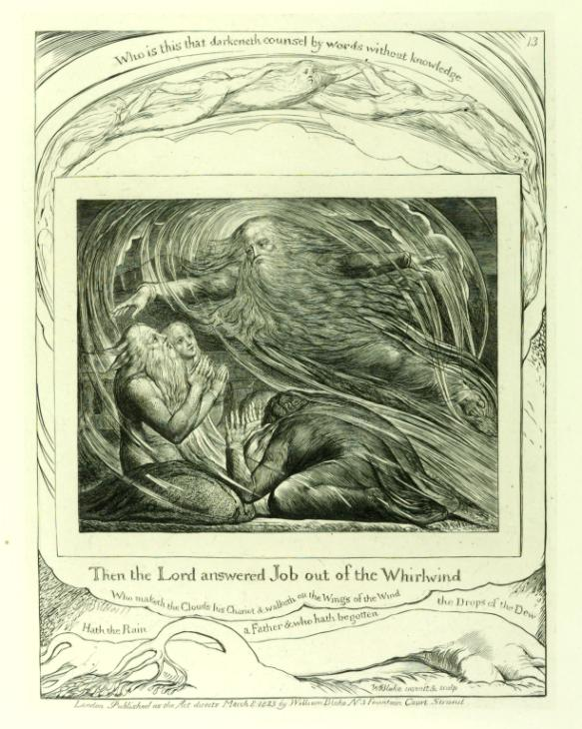
William Blake, The Lord answering Job out of the whirlwind, Tate Gallery

1 There was once a man in the land of Uz whose name was Job. That man was blameless and upright, one who feared God and turned away from evil. [1: 1]
8 The Lord said to Satan, "Have you considered my servant Job? There is no one like him on the earth, a blameless and upright man who fears God and turns away from evil."
9 Then Satan answered the Lord, "Does Job fear God for nothing?
11 But stretch out your hand now, and touch all that he has, and he will curse you to your face." [1:8-9, 11]
20 The Lord said to Satan, "Very well, all that he has is in your power; only do not stretch out your hand against him!" So Satan went out from the presence of the Lord. [1:20]

[Satan caused a storm in which Job lost all his children. Later, Job lost all property and servants in another disaster. When Job learned what disasters hit him, he responded:]
21 [Job] said, "Naked I came from my mother's womb, and naked shall I return there; the Lord gave, and the Lord has taken away; blessed be the name of the Lord." [1:21]

[Satan was, however, not convinced of Job’s steadfastness and pleaded with God to inflict another suffering on Job.]
7 So Satan […] inflicted loathsome sores on Job from the sole of his foot to the crown of his head.
8 Job took a potsherd with which to scrape himself, and sat among the ashes.
9 Then his wife said to him, "Do you still persist in your integrity? Curse God, and die."
10 But he said to her, "You speak as any foolish woman would speak. Shall we receive the good at the hand of God, and not receive the bad?" In all this Job did not sin with his lips. [2:7-10]

[Despite his suffering and torments Job continue to be faithful to Yahve. His three friends although in the beginning they consoled him and took pity of him, later, they defended the tradition of retribution on earth – Job’s suffering must be just because it is caused by his sins. All the time though, Job maintained his innocence and wondered why God allows innocent to suffer.]
11 "Why did I not die at birth, come forth from the womb and expire?
12 Why were there knees to receive me, or breasts for me to suck? [3:11-12]

25 Truly the thing that I fear comes upon me, and what I dread befalls me. [3:25]

17 What are human beings, that you make so much of them, that you set your mind on them,
18 visit them every morning, test them every moment?
20 If I sin, what do I do to you, you watcher of humanity? Why have you made me your target? Why have I become a burden to you? [7:17-20]

15 Therefore I am terrified at his presence; when I consider, I am in dread of him.
16 God has made my heart faint; the Almighty has terrified me; [23:15-16]

35 O that I had one to hear me! (Here is my signature! Let the Almighty answer me!) O, that I had the indictment written by my adversary!
36 Surely I would carry it on my shoulder; I would bind it on me like a crown;
37 I would give him an account of all my steps; like a prince I would approach him. [31:35-37]

[After Job challenged God, Yahve appeared to him in a whirlwind and spoke to Job about his power over nature, his power to create and destroy, the mystery of life and death. In the end, Job admits his humiliation by Yahve. In the final argument of his power Yahve revealed the mystery of evil represented by Behemoth, a mysterious beast from Egypt resembling a hippopotamus and Leviathan. The Book of Job ends with God blessing Job even more than before and punishing his three friends. Job humiliated by Yahve’s power over the entire world, repented his complains.]
5 I had heard of you by the hearing of the ear, but now my eye sees you;
6 therefore I despise myself, and repent in dust and ashes." [42:5-6]

10 And the Lord restored the fortunes of Job when he had prayed for his friends; and the Lord gave Job twice as much as he had before.
12 The Lord blessed the latter days of Job more than his beginning; and he had fourteen thousand sheep, six thousand camels, a thousand yoke of oxen, and a thousand donkeys. [42:10,12]

Other Hebrew words expressing fear are used in the Book of Job: בָּהַל bâhal, to tremble, to be alarmed or agitated; pâchad to be startled fear, be afraid, stand in awe, (be in) fear, make to shake.

Questions for reflections
How did Job respond to his suffering – did he accept his suffering as a punishment for his wrongdoing as his friends urged him and as the tradition of retribution claimed?
How could we explain the contrast between Adam and Eve and Job? How did Adam and Eve approach Yahve and how did Job? Did all three of them display fear of God?
Where was Job’s conviction of his innocence coming from? What Job’s break with the tradition of retribution tell us? [The Genesis refers to a very distant past in the development of mankind. The Book of Job was written probably around 500 BC. What change can we discern in human attitude to God?]
Can we recognize ourselves in Job’s grumbling against his misfortunes? Do we explain our sicknesses or adversities as God’s punishment? In what circumstances can we be humiliated?
Do we feel fear of God in ourselves? Do we feel fear of the Christ?
Do you think that the physical presence of the Christ on earth affected how the Apostles and other people who had contact with Him changed their attitude to the Divinity and softened the feeling of fear?

[Prepared with reverence by Maria L. de Ris]

