Scourging and Smiting – an Essential Part of the Passion

A lesson to accept adversities of life – with forgiveness and love

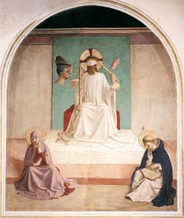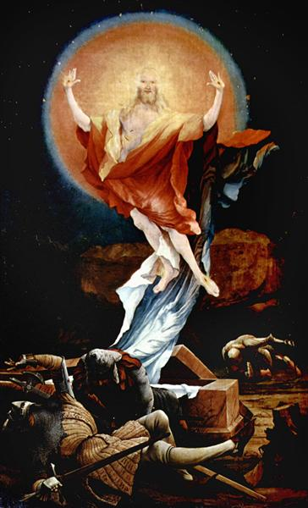
Fra Angelico (ca 1400-1455), Matthias Grünewald,
Mocking of Christ, ca 1440-41 The Resurrection of Christ, ca 1512-16

Why did Jesus Christ’s passage to His Resurrection include washing of the feet, scourging, crowning with thorns, bearing the cross and crucifixion? Could His Resurrection be possible without that suffering? Likewise, could Christ’s Resurrection be possible without his voluntary act of acceptance of suffering?

Scourging, mentioned in all four Gospels, is an integral part of the Christ’s Passion. Thus, it should be natural to ask what could the scourging of Jesus Christ signify for us and our contemporaries living in the 21st century? In the scene of scourging, a public spectacle, ordered by high authorities, we can see a physical body of a human person deliberately deprived of its dignity and mutilated. One of the purposes of flagging was to maim and mutilate the physical body – to tear the skin and muscles so that the death of the victim was imminent. It was a terribly bloody and painful experience. To avoid distress, the very natural representation of Christ’s flagellation by Peter Rubens is placed at the end of this document.

What whacks and blows could come upon us? An illness, bullying, segregation, isolation, hostility, public shaming on social media… Or a calamity caused by nature – flooding, earthquakes, fires… Or even being part of a society subjected to the enmity and violence as we see, for instance in Israel, Gaza, Ukraine, Myanmar, Sudan… As we suffer under the blows and are overwhelmed by them where can we expect and imagine resurrection?

Perhaps in the thought that there is a spiritual reality behind the matter and an imperishable part of the human person, our soul and spirit, that no whack of a whip can destroy. Or in the strength we feel whenever we overcome our own anxieties and fears and accept and face the “scourging” and forgive the perpetrators. And finally, in this powerful image of forgiveness and acceptance out of love that led to Christ Resurrection.

Yet, we should remember that Christ was only a victim, but we can be the perpetrators, the victims, and the bystanders.

Mark 15:12-15
12 Pilate spoke to them again, "Then what do you wish me to do with the man you call the King of the Jews?"
13 They shouted back, "Crucify him!"
14 Pilate asked them, "Why, what evil has he done?" But they shouted all the more, "Crucify him!"
15 So Pilate, wishing to satisfy the crowd, released Barabbas for them; and after flogging Jesus, he handed him over to be crucified.

Matthew 26: 65-68
65 Then the high priest tore his clothes and said, "He has blasphemed! Why do we still need witnesses? You have now heard his blasphemy.
66 What is your verdict?" They answered, "He deserves death."
67 Then they spat in his face and struck him; and some slapped him,
68 saying, "Prophesy to us, you Messiah! Who is it that struck you?"

Matthew 27:24-26
24 So when Pilate saw that he could do nothing, but rather that a riot was beginning, he took some water and washed his hands before the crowd, saying, "I am innocent of this man's blood; see to it yourselves."
25 Then the people as a whole answered, "His blood be on us and on our children!"
26 So he released Barabbas for them; and after flogging Jesus, he handed him over to be crucified.

Luke 23:11; 20-22
11 Even Herod with his soldiers treated him with contempt and mocked him; then he put an elegant robe on him, and sent him back to Pilate.
[…]
20 Pilate, wanting to release Jesus, addressed them again;
21 but they kept shouting, "Crucify, crucify him!
22 A third time he said to them, "Why, what evil has he done? I have found in him no ground for the sentence of death; I will therefore have him flogged and then release him."

John 19:1-4
1 Then Pilate took Jesus and had him flogged.

Questions for reflection
What forms of “scourging and smiting” did you encounter? Would you include in them phenomena such as: bullying, slander, hostility (including towards those whose political/ religious views you don’t like, as in so called cancel culture – blocking speakers), slander, etc.)?

What do you think is the intended purpose of “scourging” for the victim and for the bystanders (onlookers?) (Often such acts are performed in public, for instance martyrdom of the first Christians in the Colosseum, burning of infidels or witches on the stake, public executions, etc. Nowadays a cruel form of “scourging” is shaming individuals on social media.)

Which of life’s adversities are the most difficult for you to accept? What factors help you to accept them?

How can we develop a moral imagination that would move our conscience and allowed us to look beyond the superficial and often alluring aspects of reality and recognize the true intentions/reality/, etc.?

How can we understand the words of Isaiah (53:5):
But he was wounded for our transgressions, crushed for our iniquities; upon him was the punishment that made us whole, and by his bruises we are healed.
How are we made “whole” and “healed” by the Christ’s passion? Do we feel “whole” and “healed”?

When do we comply with the Christ’s admonitions given in His Sermon on the Mount and when we struggle with our adversaries?

Matthew 5:39-41 (Luke 6:29)
39 But I say to you, Do not resist an evildoer. But if anyone strikes you on the right cheek, turn the other also;
40 and if anyone wants to sue you and take your coat, give your cloak as well;
41 and if anyone forces you to go one mile, go also the second mile.

What the examples of Alexei Navalny who decided to return to Russia after he was healed from Novichok poisoning in Germany, or Dietrich Bonhoeffer, the German theologian, who returned to Nazi Germany shortly after WWII began, or Martin Luther King who struggled against segregation teaches us?

Why is this prayer so powerful? Is it easy to accept suffering with equanimity? Is it easy to face our own imperfections and work with them?

God, grant me the serenity to accept the things I cannot change,
the courage to change the things I can,
and the wisdom to know the difference.
(Reinhold Niebuhr)

Further reflection
Overcoming the suffering of “scourge” or any other physical or psychological violence by forgiving the perpetrators or reconciling with the circumstance, even if that occurs after a long time and a painful work, yields the fruit, the virtue of courage, spiritual strength, and freedom.

Mandy Ogunmokum is an example of a person who could relate to Christ’s scourging and mocking because she felt that she had been treated in the same way in her life – she was abused by others, she abused drugs, alcohol, and her own body. Her second home for over two decades was a prison where she spent shorter or longer periods of time for petty crimes and where she felt safe. Her encounter with a Christian group that worked with drug addicts became her saving grace. She was particularly inspired by a former, now recovered, drug addict whom she knew in the past. After some years of rehab, she recovered from addiction and subsequently became mentor for other women.

How could we, as a church community, reach out to people who need support and love and care?

“Her own story began in 1960s Yorkshire, where she grew up with her mother and her grandmother. Alcohol was readily available, since her mum was a heavy drinker, and she had her first drink at 10. She didn’t like the taste, but its effects felt like a brief respite from the chaos of growing up in a household where her family were sex workers. […]”

“I didn’t want to be put in a box in the church because I’ve been put in a box my whole life,” she says. “But the fact that Jesus was spat upon, despised and rejected was something I could identify with. I had to keep going.”

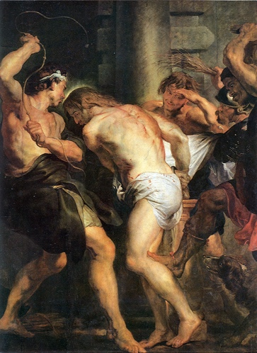
Peter Paul Rubens (1577-1640), Flagellation of Christ
Picture attribution
https://www.wga.hu/html_m/a/angelico/09/cells/07_chris.html
https://www.wikiart.org/en/matthias-grunewald/the-resurrection-of-christ-right-wing-of-the-isenheim-altarpiece-1516
https://en.m.wikipedia.org/wiki/File:Flagellation-of-christ-_Rubens.jpg

Sources
“I was an addict, a prisoner, a sex worker.” By Ammar Kalia:
https://www.theguardian.com/lifeandstyle/2024/jan/31/i-was-an-addict-prisoner-sex-worker-i-saved-myself
Valentin Tomberg, Christ and Sophia. Anthroposophic Meditations on the Old, New Testament & Apocalypse, (Great Barrington, MA: SteinerBooks, 2006).

[Prepared with reverence by Maria L. de Ris]

