Angels Protecting Christ’s Mission

St. Luke’s Gospel – announcements of the birth of John and Jesus

Angel Gabriel meets Zechariah

Luke 1: 8-22
8 Once when [Zechariah] was serving as priest before God and his section was on duty,
9 he was chosen by lot, according to the custom of the priesthood, to enter the sanctuary of the Lord and offer incense. […]
11 Then there appeared to him an angel of the Lord, standing at the right side of the altar of incense.
12 When Zechariah saw him, he was terrified; and fear overwhelmed him.
13 But the angel said to him, "Do not be afraid, Zechariah, for your prayer has been heard. Your wife Elizabeth will bear you a son, and you will name him John. […]
17 With the spirit and power of Elijah he will go before him, […] to make ready a people prepared for the Lord."
18 Zechariah said to the angel, "How will I know that this is so? […]
19 The angel replied, "I am Gabriel. I stand in the presence of God, and I have been sent to speak to you and to bring you this good news.

Angel Gabriel appears to Mary

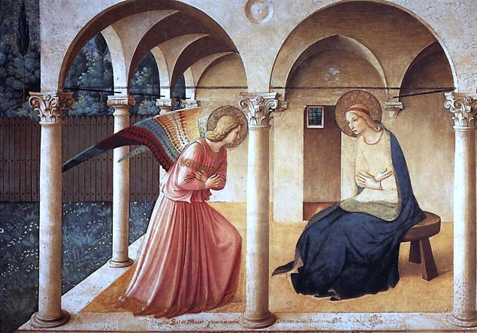
Luke 1: 26-38
26 In the sixth month the angel Gabriel was sent by God to a town in Galilee called Nazareth,
27 to a virgin engaged to a man whose name was Joseph, of the house of David. The virgin's name was Mary.
28 And he came to her and said, "Greetings, favored one! The Lord is with you."
29 But she was much perplexed by his words and pondered what sort of greeting this might be.
30 The angel said to her, "Do not be afraid, Mary, for you have found favor with God.
31 And now, you will conceive in your womb and bear a son, and you will name him Jesus. […]
38 Then Mary said, "Here am I, the servant of the Lord; let it be with me according to your word." Then the angel departed from her.

Angel announces the birth of Jesus to the shepherds

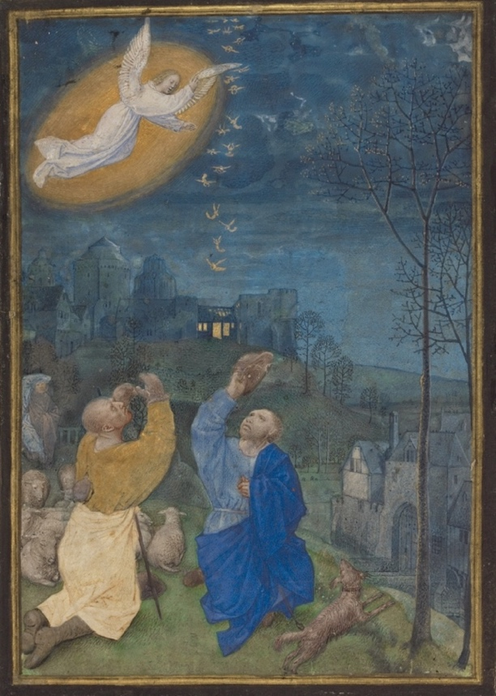
Luke 2: 8-14
8 In that region there were shepherds living in the fields, keeping watch over their flock by night.
9 Then an angel of the Lord stood before them, and the glory of the Lord shone around them, and they were terrified.
10 But the angel said to them, "Do not be afraid; for see—I am bringing you good news of great joy for all the people:
11 to you is born this day in the city of David a Savior, who is the Messiah, the Lord.
12 This will be a sign for you: you will find a child wrapped in bands of cloth and lying in a manger."
13 And suddenly there was with the angel a multitude of the heavenly host, praising God and saying,
14 "Glory to God in the highest heaven, and on earth peace among those whom he favors!"

Questions for reflections
Were the responses to the Angel’s message by Zechariah, Mary, and the shepherds different? How do you think you would respond in such a surprising situation? Would you also be struck with fear?
Could Zechariah, Mary and the shepherds have had any doubts about the Angel and the message?
Why the Angel had to visit Zechariah, Mary, and some shepherds to announce the birth of Jesus?
What could have been the shepherd’s imagination of the Messiah? ‘
What contrasts can we find between these three scenes and the Fall – the expulsion of Adam and Eve from the Paradise?
Do you often respond with fear, startle, shock to the unknown, unexpected, or unusual situation or appearance?

St. Matthew’s Gospel – messages for Joseph to protect Mary and her child

An Angel appears to Joseph in dreams

Matthew 1: 18-24
18 Now the birth of Jesus the Messiah took place in this way. When his mother Mary had been engaged to Joseph, but before they lived together, she was found to be with child from the Holy Spirit.
19 Her husband Joseph, being a righteous man and unwilling to expose her to public disgrace, planned to dismiss her quietly.
20 But just when he had resolved to do this, an angel of the Lord appeared to him in a dream and said, "Joseph, son of David, do not be afraid to take Mary as your wife, for the child conceived in her is from the Holy Spirit.
21 She will bear a son, and you are to name him Jesus, for he will save his people from their sins."[…]
24 When Joseph awoke from sleep, he did as the angel of the Lord commanded him; he took her as his wife,

Matthew 2: 13-20
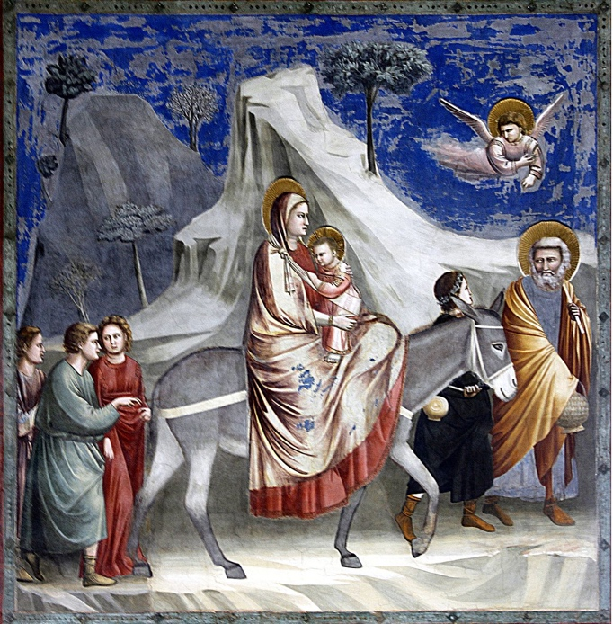
By © José Luiz Bernardes Ribeiro, CC BY-SA 4.0,
https://commons.wikimedia.org/w/index.php?curid=52228577

13 Now after [the three wise men from the East] had left, an angel of the Lord appeared to Joseph in a dream and said, "Get up, take the child and his mother, and flee to Egypt, and remain there until I tell you; for Herod is about to search for the child, to destroy him."
14 Then Joseph got up, took the child and his mother by night, and went to Egypt,
15 and remained there until the death of Herod. This was to fulfill what had been spoken by the Lord through the prophet, "Out of Egypt I have called my son."
16 When Herod saw that he had been tricked by the wise men, he was infuriated, and he sent and killed all the children in and around Bethlehem who were two years old or under, according to the time that he had learned from the wise men.[…]
19 When Herod died, an angel of the Lord suddenly appeared in a dream to Joseph in Egypt and said,
20 "Get up, take the child and his mother, and go to the land of Israel, for those who were seeking the child's life are dead."

Questions for reflection
Why do you think Luke describes only appearing of an angel to Mary and doesn’t mention anything about Joseph? Why, on the other hand, Matthew Gospel presents only an angel appearing to Joseph?
Could there be a difference between seeing and angel, just like Zechariah, shepherds, or Mary, or dreaming of an appearance of an angel, as it was happening to Joseph?
Matthew Gospel traces the genealogy of Jesus to Abraham (through the line of David’s son Solomon); Luke’s Gospel traces it to Adam (through the line of David’s son Nathan). How could we interpret these two genealogies and what they could mean for the understanding of the mission of Christ for us, Christians?

Angels in the service of the Son of Man

John 1: 48-51
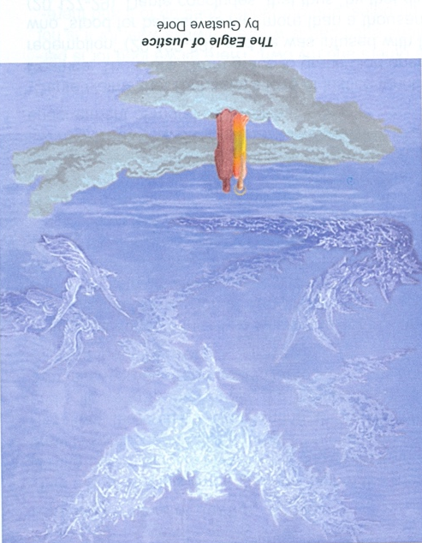

48 Nathanael asked him, "Where did you get to know me?" Jesus answered, "I saw you under the fig tree before Philip called you."
49 Nathanael replied, "Rabbi, you are the Son of God! You are the King of Israel!"
50 Jesus answered, "Do you believe because I told you that I saw you under the fig tree? You will see greater things than these."
51 And he said to him, "Very truly, I tell you, you will see heaven opened and the angels of God ascending and descending upon the Son of Man."

Questions for reflection
Is this vision of angels ‘ascending and descending upon the Son of Man’ consistent with the description of the role of angels appearing to various individuals: Mary, Joseph, Mary Magdalene, and other?
What relationship could we find between the description of Jacob dreaming of descending and ascending of angels and this description of Jesus?
From Genesis 28:12-14: And he dreamed that there was a ladder set up on the earth, the top of it reaching to heaven; and the angels of God were ascending and descending on it.
13 And the Lord stood beside him and said, "I am the Lord, the God of Abraham your father and the God of Isaac; the land on which you lie I will give to you and to your offspring;
14 and your offspring shall be like the dust of the earth, and you shall spread abroad to the west and to the east and to the north and to the south; and all the families of the earth shall be blessed in you and in your offspring.

Angels in the empty tomb

Luke 24: 1-5
1 But on the first day of the week, at early dawn, they came to the tomb, taking the spices that they had prepared.
2 They found the stone rolled away from the tomb,
3 but when they went in, they did not find the body.
4 While they were perplexed about this, suddenly two men in dazzling clothes stood beside them.
5 The women were terrified and bowed their faces to the ground, but the men said to them, "Why do you look for the living among the dead? He is not here, but has risen.

Matthew 28:2-7

2 And suddenly there was a great earthquake; for an angel of the Lord, descending from heaven, came and rolled back the stone and sat on it.
3 His appearance was like lightning, and his clothing white as snow.
4 For fear of him the guards shook and became like dead men.
5 But the angel said to the women, "Do not be afraid; I know that you are looking for Jesus who was crucified.
6 He is not here; for he has been raised, as he said. Come, see the place where he lay.
7 Then go quickly and tell his disciples, "He has been raised from the dead, and indeed he is going ahead of you to Galilee; there you will see him.' This is my message for you."

John 20: 11-14
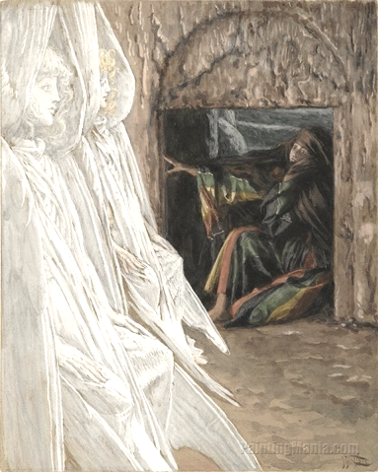
11 But Mary stood weeping outside the tomb. As she wept, she bent over to look into the tomb;
12 and she saw two angels in white, sitting where the body of Jesus had been lying, one at the head and the other at the feet.
13 They said to her, "Woman, why are you weeping?" She said to them, "They have taken away my Lord, and I do not know where they have laid him."
14 When she had said this, she turned around and saw Jesus standing there, but she did not know that it was Jesus. […]

Questions for reflection
Why does the Matthew Gospel mention that the angel had to roll back the stone covering the tomb and Luke doesn’t mention that? Could we assume that the angels or other supernatural beings removed the stone?
What can we say about the description of the angels presented in all Gospels: ‘His appearance was like lightning, and his clothing white as snow’; ‘two men in dazzling clothes stood beside them’, ‘the glory of the Lord shone around them’, and ‘two angels in white’? What attributes do we usually assign to angels? How these descriptions correspond to what Jesus spoke about himself ‘I’m the light of the world’ [Jn 8:12], or John wrote about Jesu: ‘The true light, which enlightens everyone, was coming into the world. [1:9]?
How could we interpret the number of angels standing in the tomb?
All Gospels and many books in the Old Testament use the expression ‘the angel of the Lord’ how is the Christ mission related to the role of angels?

A brief summary of the first part of our Bible reflection on angels

The most comprehensive description of the angelic hierarchies was presented by Pseudo Dionysius the Areopagite in his work “The Celestial Hierarchy”. He described three hierarchies each with three additional levels of angelic beings which are:

The first hierarchy: Seraphim (Latin seraphim, Hebrew seraphim: “fire makers”, spirits of all-love); Cherubim (lat. cherubim, Hebr. Cherubim: “fullness of knowledge/outpouring wisdom”, spirits of the harmonies); Thrones (gr. thronoi, lat. throni, Hebr. aralim, spirits of the will)
The second hierarchy: Kyriotetes (lat. dominationes, Hebr. Tarshishim, dominions, Spirits of Wisdom); Dynamis (lat. virtutes, Hebr. Hashmalim, powers, Spirits of Motion); Exusiai (lat. potestates, Hebrew Elohim, powers, Spirits of Form)
The third hierarchy: Archai (lat. principates, principalities, primal angels, primal powers, spirits of personality); Archangeloi (lat. archangeli, archangels, sons of fire, spirits of fire, arch messengers); Angeloi (lat. angeli, angels, sons of twilight, spirits of twilight, sons of life, messengers)

In our reflection we focused on some of the appearances of Angels mentioned in the Old Testament. discussed the role of the cherub, who was watching the garden of Eden after the expulsion of Adam and Eve. We talked about Jacob’s encounters with angels – his dream of Angels ascending and descending on a ladder, and his wresting with an Angel. We also brought up the role of seraphs in the visions of Isaiah and in the Book of Revelation – the six-winged angelic beings whose role is to glorify God.

Picture attributions

Page 1: Fra Angelico, ca. 1437-46. Annunciation
https://en.wikipedia.org/wiki/Fra_Angelico#/media/File:ANGELICO,_Fra_Annunciation,_1437-46_(2236990916).jpg

Page 2: Flemish miniature from 15th century – Annunciation to the Shepherds
https://en.wikipedia.org/wiki/Annunciation_to_the_shepherds#/media/File:Annunciation_to_the_Shepherds_-_Emerson-White_Hours_-_Getty_Museum_Ms60.jpg

Page 3: Giotto di Bondone, The Flight to Egypt,
https://en.wikipedia.org/wiki/Flight_into_Egypt#/media/File:Flight_into_Egypt_-_Capella_dei_Scrovegni_-_Padua_2016.jpg
Page 4: Gustave Dore, L’aquila delle anime (Paradiso, canto XIX)
https://commons.wikimedia.org/wiki/File:Par_19_aquila.jpg

Page 6: James Tissot, Mary Magdalene Questions the Angels in the Tomb
https://commons.wikimedia.org/wiki/File:Brooklyn_Museum_-_Mary_Magdalene_Questions_the_Angels_in_the_Tomb_%28Madeleine_dans_le_tombeau_interroge_les_anges%29_-_James_Tissot.jpg

