How Artists Portrayed Matthew and Luke’s Descriptions of Jesus Nativity

[All quotes from the Matthew Gospel are marked in green, from Luke in blue.]

Genealogy of Jesus
1:1 An account of the genealogy of Jesus the Messiah, the son of David, the son of Abraham.
[…]
1:16and Jacob the father of Joseph the husband of Mary, of whom Jesus was born, who is called the Messiah.

3:23 Jesus was about thirty years old when he began his work. He was the son (as was thought) of Joseph son of Heli,
[…]
3:38 son of Enos, son of Seth, son of Adam, son of God.

Joseph’s Hesitation and Mary’s Surrender to her Mission

1:18 Now the birth of Jesus the Messiah took place in this way. When his mother Mary had been engaged to Joseph, but before they lived together, she was found to be with child from the Holy Spirit.
1:19 Her husband Joseph, being a righteous man and unwilling to expose her to public disgrace, planned to dismiss her quietly.
1:20 But just when he had resolved to do this, an angel of the Lord appeared to him in a dream and said, "Joseph, son of David, do not be afraid to take Mary as your wife, for the child conceived in her is from the Holy Spirit.
1:21 She will bear a son, and you are to name him Jesus, for he will save his people from their sins."
1:22 All this took place to fulfill what had been spoken by the Lord through the prophet:
1:23 "Look, the virgin shall conceive and bear a son, and they shall name him Emmanuel," which means, "God is with us."
1:24 When Joseph awoke from sleep, he did as the angel of the Lord commanded him; he took her as his wife,
1:25 but had no marital relations with her until she had borne a son; and he named him Jesus.

1:26 In the sixth month the angel Gabriel was sent by God to a town in Galilee called Nazareth,
1:27 to a virgin engaged to a man whose name was Joseph, of the house of David. The virgin's name was Mary.
1:28 And he came to her and said, "Greetings, favored one! The Lord is with you."
1:29 But she was much perplexed by his words and pondered what sort of greeting this might be.
1:30 The angel said to her, "Do not be afraid, Mary, for you have found favor with God.
1:31 And now, you will conceive in your womb and bear a son, and you will name him Jesus.
1:32 He will be great, and will be called the Son of the Most High, and the Lord God will give to him the throne of his ancestor David.
1:33 He will reign over the house of Jacob forever, and of his kingdom there will be no end."
1:35 The angel said to her, "The Holy Spirit will come upon you, and the power of the Most High will overshadow you; therefore the child to be born will be holy; he will be called Son of God.
1:36 And now, your relative Elizabeth in her old age has also conceived a son; and this is the sixth month for her who was said to be barren.
1:37 For nothing will be impossible with God."
1:38 Then Mary said, "Here am I, the servant of the Lord; let it be with me according to your word." Then the angel departed from her.

Annunciation
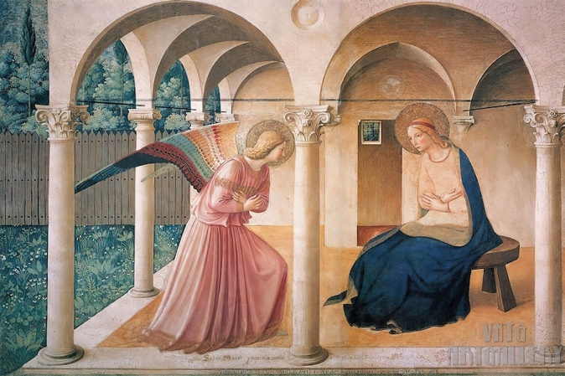 Fra Angelico, c.1440-
1445, Convent of San Marco, Florence
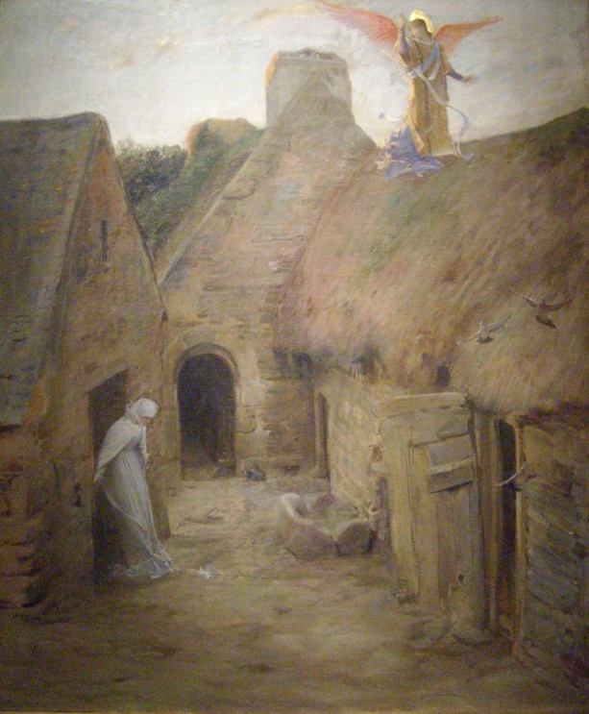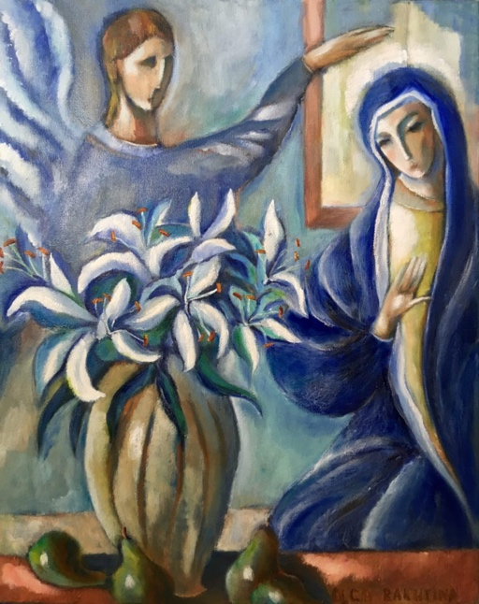
Luc-Oliver Merson, 1908 Olga Bakhtina, 2020

The Birth of Jesus

2:1 In the time of King Herod, after Jesus was born in Bethlehem of Judea, wise men from the East came to Jerusalem,

2:1 In those days a decree went out from Emperor Augustus that all the world should be registered.
2:2 This was the first registration and was taken while Quirinius was governor of Syria.
2:3 All went to their own towns to be registered.
2:4 Joseph also went from the town of Nazareth in Galilee to Judea, to the city of David called Bethlehem, because he was descended from the house and family of David.
2:5 He went to be registered with Mary, to whom he was engaged and who was expecting a child.
2:6 While they were there, the time came for her to deliver her child.
2:7 And she gave birth to her firstborn son and wrapped him in bands of cloth, and laid him in a manger, because there was no place for them in the inn.

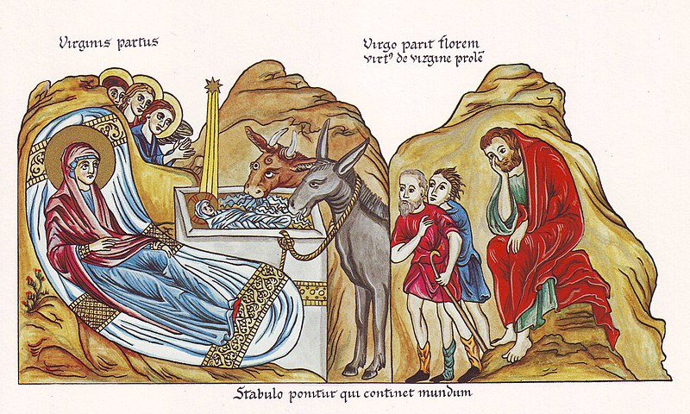
Jesus Nativity, from an illuminated encyclopedia, compiled by a nun Herrad von Hohenburg, circa 1180,
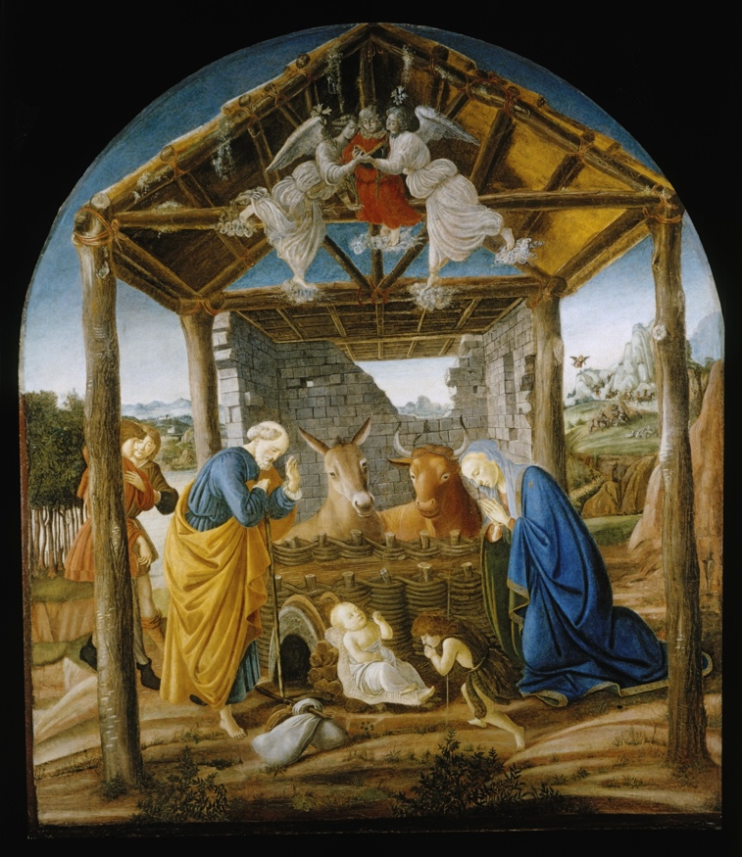 Botticelli, c. 1473–1475
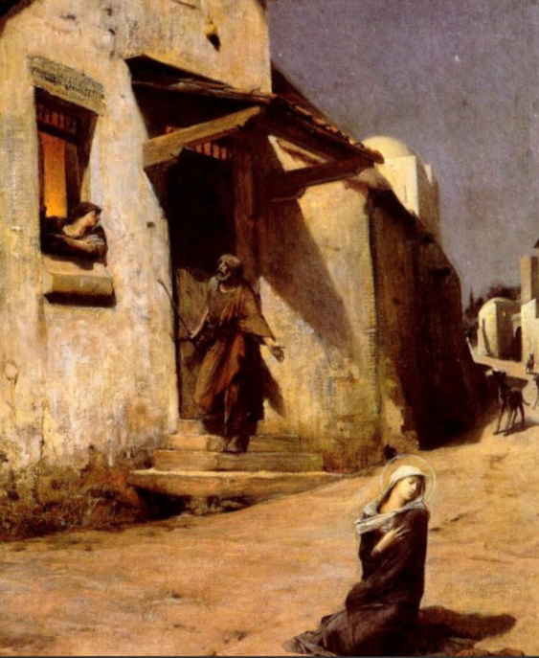
Luc-Oliver Merson, The Arrival at Bethlehem, 1897

Adoration of the Magi
12:1 In the time of King Herod, after Jesus was born in Bethlehem of Judea, wise men from the East came to Jerusalem,
2:2 asking, "Where is the child who has been born king of the Jews? For we observed his star at its rising, and have come to pay him homage."
2:3 When King Herod heard this, he was frightened, and all Jerusalem with him;
2:4 and calling together all the chief priests and scribes of the people, he inquired of them where the Messiah was to be born.
2:5 They told him, "In Bethlehem of Judea; for so it has been written by the prophet:
2:6 "And you, Bethlehem, in the land of Judah, are by no means least among the rulers of Judah; for from you shall come a ruler who is to shepherd my people Israel.' "
2:7 Then Herod secretly called for the wise men and learned from them the exact time when the star had appeared.
2:8 Then he sent them to Bethlehem, saying, "Go and search diligently for the child; and when you have found him, bring me word so that I may also go and pay him homage."
2:9 When they had heard the king, they set out; and there, ahead of them, went the star that they had seen at its rising, until it stopped over the place where the child was.
2:10 When they saw that the star had stopped, they were overwhelmed with joy.
2:11 On entering the house, they saw the child with Mary his mother; and they knelt down and paid him homage. Then, opening their treasure chests, they offered him gifts of gold, frankincense, and myrrh.

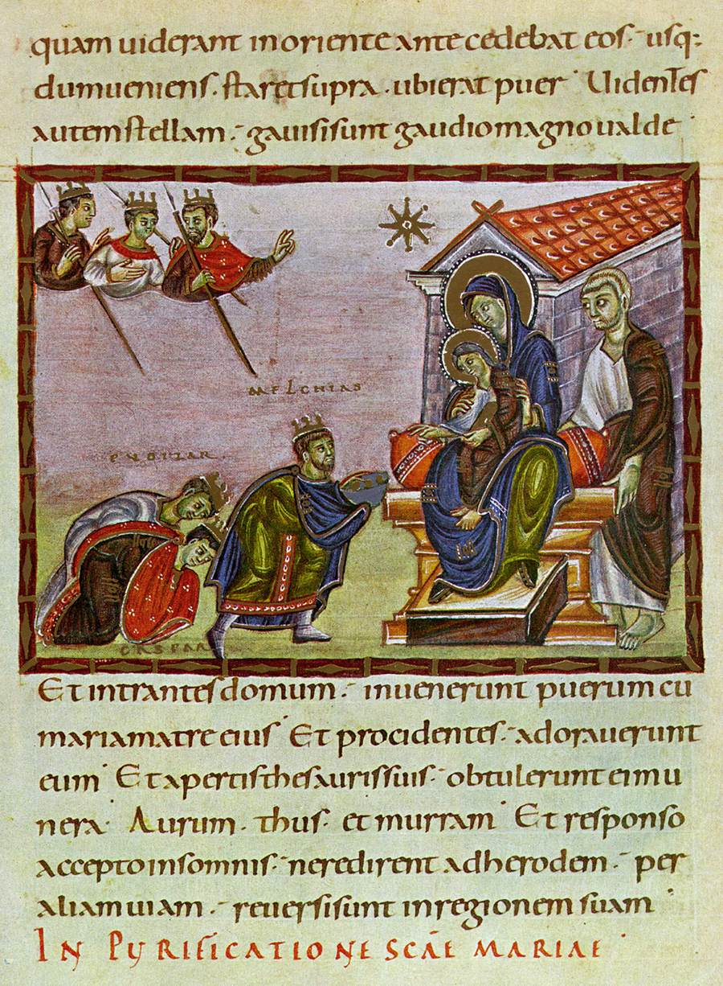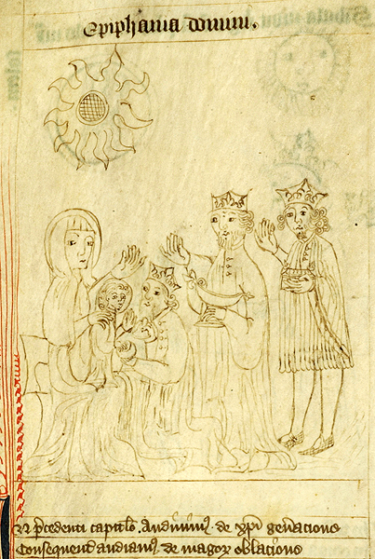
Codex Egberti, c. 980, Manuscript Speculum humanae salvationis, England,
commissioned by the Archbishop Egbert of Trier. Yorkshire?, ca. 1400

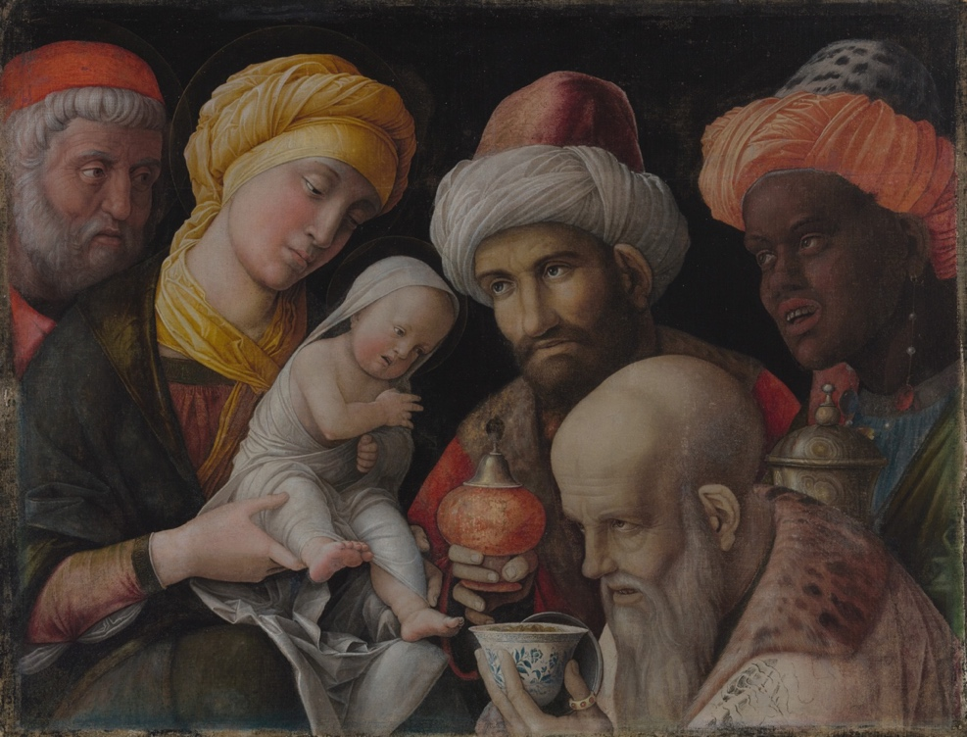
Andrea Mantegna, Adoration of the Magi, about 1495–1505
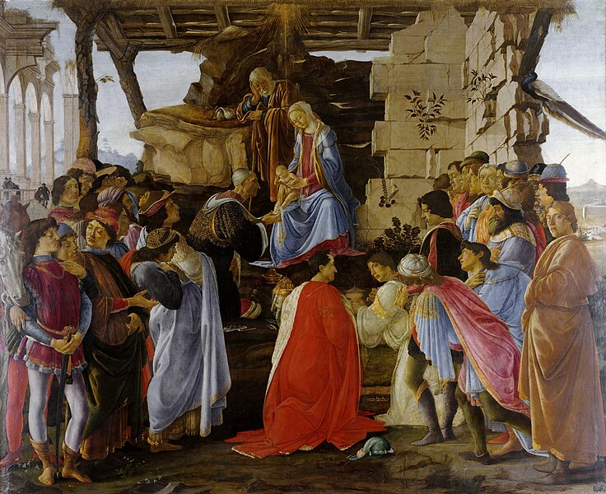
Sandro Botticelli, Adoration of the Magi, circa 1476
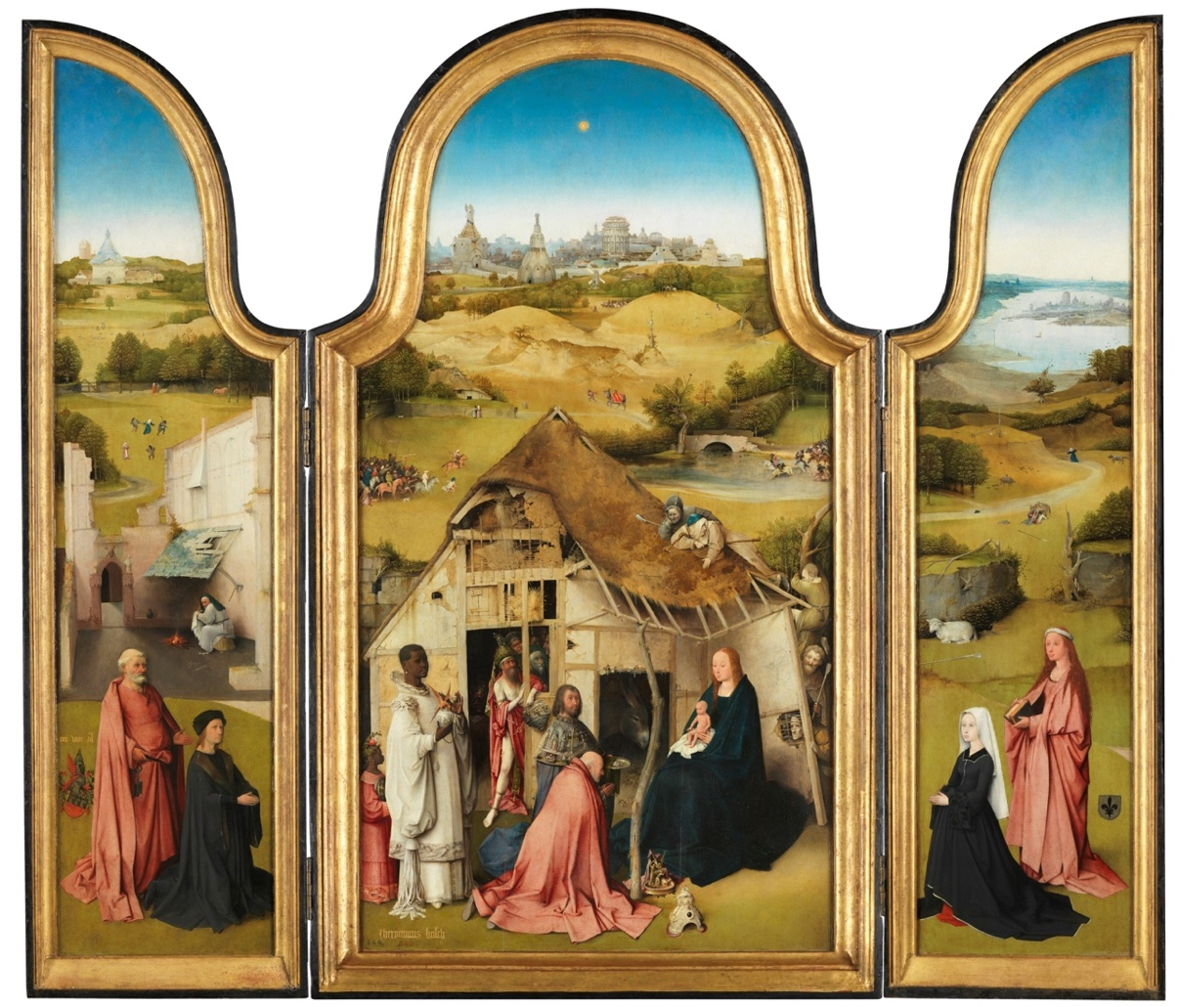
Hieronymus Bosch, the Adoration of the Magi, triptych, ca 1494
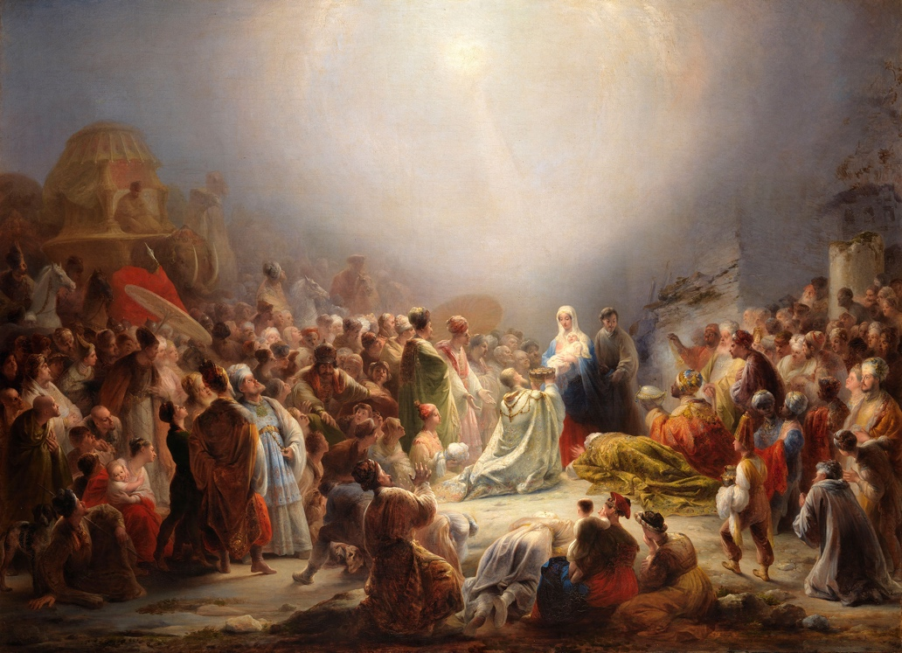
Domingos Sequiera, Adoration of the Magi, 1828

Adoration of the Shepherds

2:8 In that region there were shepherds living in the fields, keeping watch over their flock by night.
2:9 Then an angel of the Lord stood before them, and the glory of the Lord shone around them, and they were terrified.
2:10 But the angel said to them, "Do not be afraid; for see—I am bringing you good news of great joy for all the people:
2:11 to you is born this day in the city of David a Savior, who is the Messiah, the Lord.
2:12 This will be a sign for you: you will find a child wrapped in bands of cloth and lying in a manger."
2:13 And suddenly there was with the angel a multitude of the heavenly host, praising God and saying,
2:14 "Glory to God in the highest heaven, and on earth peace among those whom he favors!"
2:15 When the angels had left them and gone into heaven, the shepherds said to one another, "Let us go now to Bethlehem and see this thing that has taken place, which the Lord has made known to us."
2:16 So they went with haste and found Mary and Joseph, and the child lying in the manger.
2:17 When they saw this, they made known what had been told them about this child;

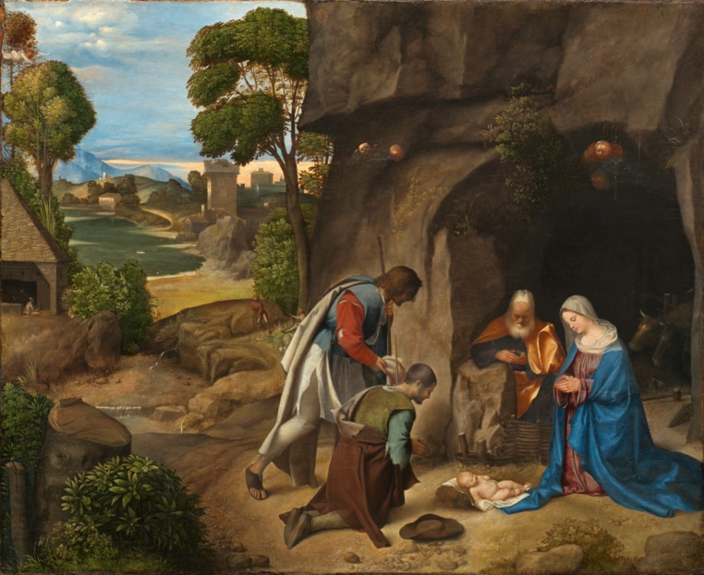
Giorgione, The Adoration of the Shepherds, 1505/1510

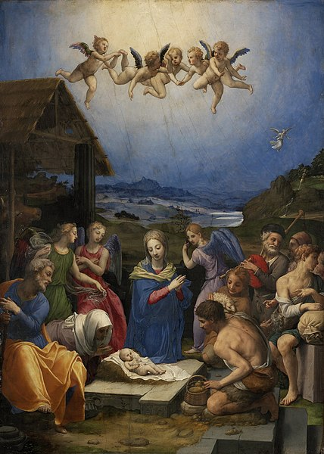 Bronzino (1503–1572)

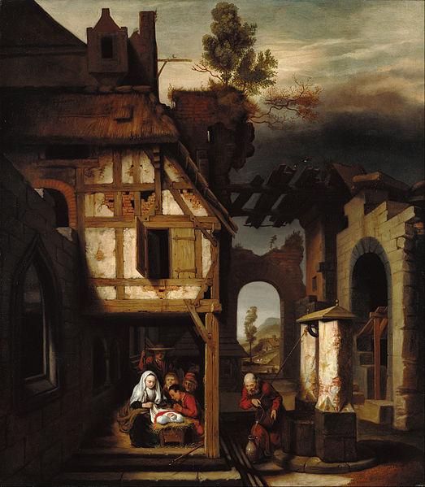 Nicolaes Maes (Dutch, 1634 - 1693)
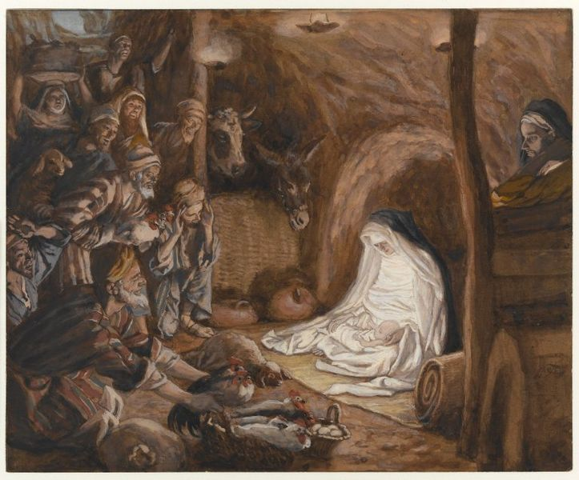
James Tissot (1836–1902), between 1886 and 1894

Flight to Egypt

2:12 And having been warned in a dream not to return to Herod, they left for their own country by another road.
13 Now after they had left, an angel of the Lord appeared to Joseph in a dream and said, "Get up, take the child and his mother, and flee to Egypt, and remain there until I tell you; for Herod is about to search for the child, to destroy him."
14 Then Joseph got up, took the child and his mother by night, and went to Egypt,
15 and remained there until the death of Herod. This was to fulfill what had been spoken by the Lord through the prophet, "Out of Egypt I have called my son."

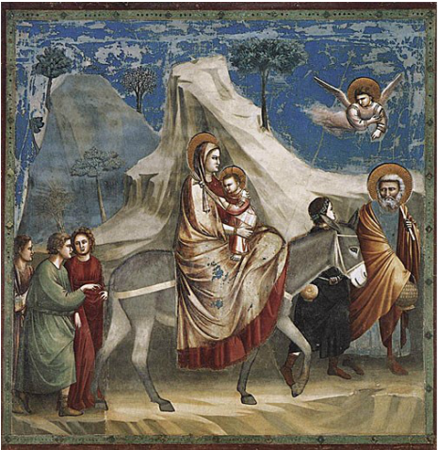 Giotto di Bondone, 1306

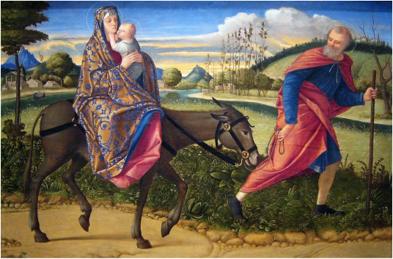 Vittore Carpaccio, 1515

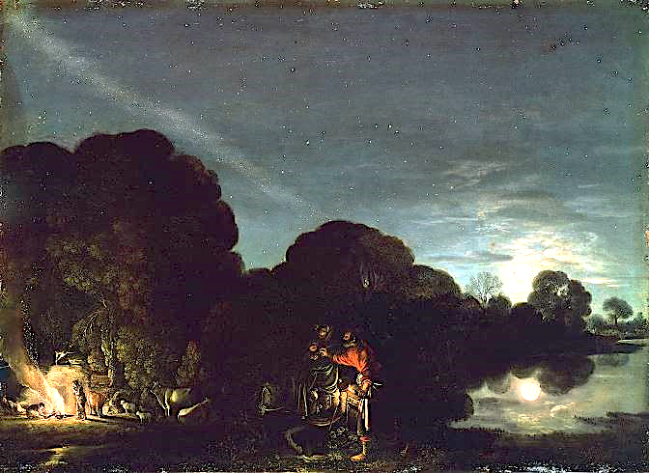
Adam Elsheimer, Flight to Egypt, 1609

[This painting is the first painting that represented night – as the flight to Egypt occurred at night. Note the Milky Way and the moon. The painter included the constellation of Leo – placed over the figure of the Christ child and the constellation of the Great Bear. Most likely Elsheimer used newly invented telescope to observe the sky.]

Sources
Most pictures were downloaded from Wikipedia.

Prepared with reverence by Maria L. de Ris

