Emotions and Feelings in Sunday’s Liturgical Prayers

The texts read or sung during the Sunday service have been carefully selected and revised many times during several centuries. Its main source is the Book of Common Prayer which was first composed in 1549 by the archbishop of Canterbury Thomas Cranmer (during King Edward VI of England) while England was separating itself from Rome.

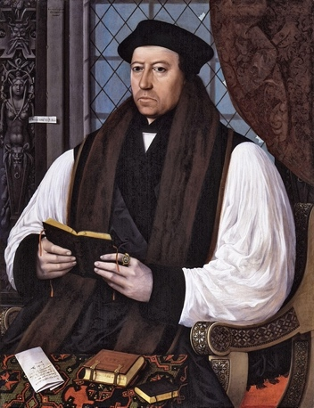Thomas Cranmer by Gerlach Flicke

This book constitutes a significant step toward worship in the native language, in English, instead of Latin, and establishing new standards (selection of vocabulary, phrases, and sentence structure) for the English language itself – as reflected in Shakespeare’s works and in the King James Bible. Many idioms, phrases initiated at that time still live in English speakers across the globe.

The Book of Common Prayer was designated for public worship and combined three books used earlier (liturgical books, prayers used for specific time of the day and specific occasions and holidays). Its spirit originates from the liturgies in synagogues (although sacrificial offerings to gods were practiced from time immemorial), specifically the forms of sacrificial prayers and praises to God but transformed to incorporate the sacrifice of Jesus Christ and His teaching encapsulated in the Gospels, epistles and the Book of Revelation.

Selected parts of the Liturgy

- Beginning of the Service - Purification of hearts

Liturgy of the Word / Collect of the Day
"Almighty God, to whom all hearts are open, all desires known, and from whom no secrets are hidden: cleanse the thoughts of our hearts by the inspiration of your Holy Spirit, that we may perfectly love you, and worthily magnify your holy name; through Christ our Lord. Amen."

Questions for reflection
Would you like to worship in Latin (or other foreign language) as it had been done until the beginning of the 16th century?
How can we explain the transition from the purification of the outside (washing parts of our body, sacrificial utensils, place) to the purification of our interiority (hearts, minds, souls)?
See: Matthew 23:25-26:
“Woe to you, scribes and Pharisees, hypocrites! For you clean the outside of the cup and of the plate, but inside they are full of greed and self-indulgence.
You blind Pharisee! First clean the inside of the cup, so that the outside also may become clean.”
Luke 11: 38-40:
The Pharisee was amazed to see that he did not first wash before dinner.
Then the Lord said to him, "Now you Pharisees clean the outside of the cup and of the dish, but inside you are full of greed and wickedness.
You fools! Did not the one who made the outside make the inside also?

How do we purify our hearts? How do we free ourselves from negative thoughts and feelings?
What does the transition from the emphasis on the exterior to the interior mean in the development of mankind?

- Invoking the Glory of God

  - Exodus 24:15-18
Then Moses went up on the mountain, and the cloud covered the mountain.
The glory of the Lord settled on Mount Sinai, and the cloud covered it for six days; on the seventh day he called to Moses out of the cloud.
Now the appearance of the glory of the Lord was like a devouring fire on the top of the mountain in the sight of the people of Israel.
Moses entered the cloud, and went up on the mountain. Moses was on the mountain for forty days and forty nights.

  - Gloria in Excelsis Deo

Luke 2:13-14
And suddenly there was with the angel a multitude of the heavenly host, praising God and saying,
"Glory to God in the highest heaven, and on earth peace among those whom he favors!"

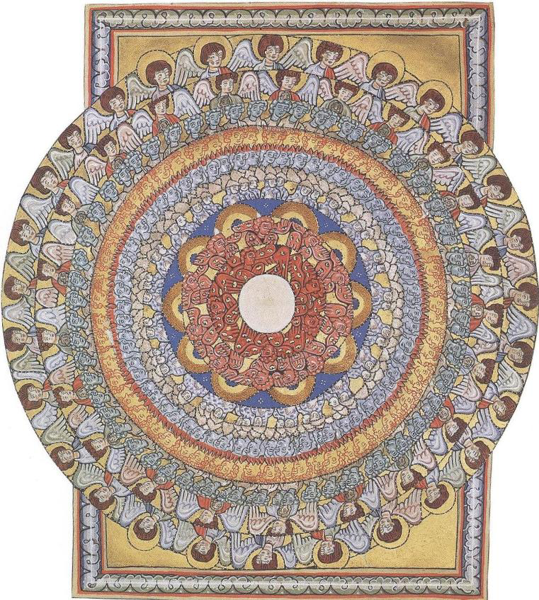
Glory to God in the highest, and peace to his people on earth.
We praise you,
we bless you,
we adore you,
we glorify you,
we give you thanks for your great glory,
Lord God, heavenly King,
O God almighty Father.
Lord Jesus Christ, Only Son of the Father,
Lord God, Lamb of God,
you take away the sins of the world,
have mercy on us;
you take away the sins of the world,
you are seated at the right hand of the Father
have mercy on us.
For you alone are the Holy One,
you alone are the Lord,
you alone are the Most High,
Jesus Christ,
with the Holy Spirit,
in the glory of God the Father.
Amen.
Hildegard von Bingen Choir of Angels

Questions for reflection
Is it possible to imagine the “glory of God” (splendor of God)?
How can we connect to what Moses experienced and to what the twelve apostles experienced?
How can we connect to what the shepherds experienced?
Is the image of the “glory of God” connected to the feeling of awe (wonderment)?
What makes you feel awe? How do you respond. When you feel awe/wonderment?
What happens to us when we feel awe? What can induce awe in us?

- Penitential Order
Confession of Sin & Absolution (Rite Two)
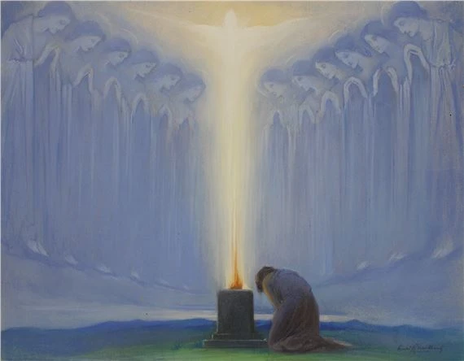
Arild Rosenkrantz, The Altar of the Soul

“Most merciful God, we confess that we have sinned against you in thought, word, and deed, by what we have done, and by what we have left undone. We have not loved you with our whole heart; we have not loved our neighbors as ourselves. We are truly sorry and we humbly repent. For the sake of your Son Jesus Christ, have mercy on us and forgive us; that we may delight in your will, and walk in your ways, to the glory of your Name. Amen.”
Absolution
“Priest: Almighty God have mercy on you, forgive you all your sins through the grace of Jesus Christ, strengthen you in all goodness, and by the power of the Holy Spirit keep you in eternal life. Amen.”
Questions for reflection
What is the effect of a group confession (“we confess) rather than an individual confession?
Why is worshiping as a group so important?
What is the meaning of the confession of sin?
Which concept speaks to you most: sin /trespass /error /missteps /wrong /fault?
What feeling arises in you when you think of something bad you have done? A feeling of shame? Contrition?
How do we clean our interiority?
Expressions of joy and thanksgiving
The Holy Communion; Eucharistic Prayer (BCP), Prayer C
Agnus Dei, Jan v. Eyck, Gent Altar 1432

“Celebrant The Lord be with you.
People And also with you [your spirit].
Celebrant Lift up your hearts.
People We lift them to the Lord.
Celebrant Let us give thanks to the Lord
our God.
People It is right to give him thanks
and praise.”
****

“For on the night that he was betrayed, our Lord Jesus Christ took bread; and when he had given thanks, he broke it,* and gave it to his disciples, saying, “Take, eat; this is my Body, which is given for you: Do this in remembrance of me.”

[Before the Ministration of Communion]
“The gifts of God for the people of God. Take them in remembrance that Christ died for you and lives for you, and feed on him in your hearts by faith, with thanksgiving.”

[The words Jesus Christ said to the apostles during the Last Supper are found in all synoptical Gospels, Matthew, Mark, and Luke]
Luke 22: 19-20
Then he took a loaf of bread, and when he had given thanks, he broke it and gave it to them, saying, "This is my body, which is given for you. Do this in remembrance of me."
And he did the same with the cup after supper, saying, "This cup that is poured out for you is the new covenant in my blood.
Matthew 26:26-28
While they were eating, Jesus took a loaf of bread, and after blessing it he broke it, gave it to the disciples, and said, "Take, eat; this is my body."
Then he took a cup, and after giving thanks he gave it to them, saying, "Drink from it, all of you;
for this is my blood of the covenant, which is poured out for many for the forgiveness of sins.
Mark 14:22-24
While they were eating, he took a loaf of bread, and after blessing it he broke it, gave it to them, and said, "Take; this is my body."
Then he took a cup, and after giving thanks he gave it to them, and all of them drank from it.
He said to them, "This is my blood of the covenant, which is poured out for many.

Questions for reflection
“Eucharist” means thanksgiving. Does that feeling fill you when you approach the altar and take the bread (wafer)?
When receiving the bread (and wine) becomes the most transformative experience for you? How do you feel union with Christ?
How do you feel the presence of Christ during the Communion?
What is the role of the priest? Do you feel connected to the person of the priest or to his/her role as a mediator between you and Christ? Reflect on the difference of the wording “The Lord be with you. And with you.”/ “And with your spirit.” Do you find a difference between “you” and “your spirit”?
Cynthia Bourgeault, an Episcopal minister and mistic, suggested to interpret the word “remembrance” as a “living presence”. Do you feel Christ presence when you take a Eucharist?
Do we recognize Jesus Christ as the Sacrificial Lamb for all of us, for all mankind?

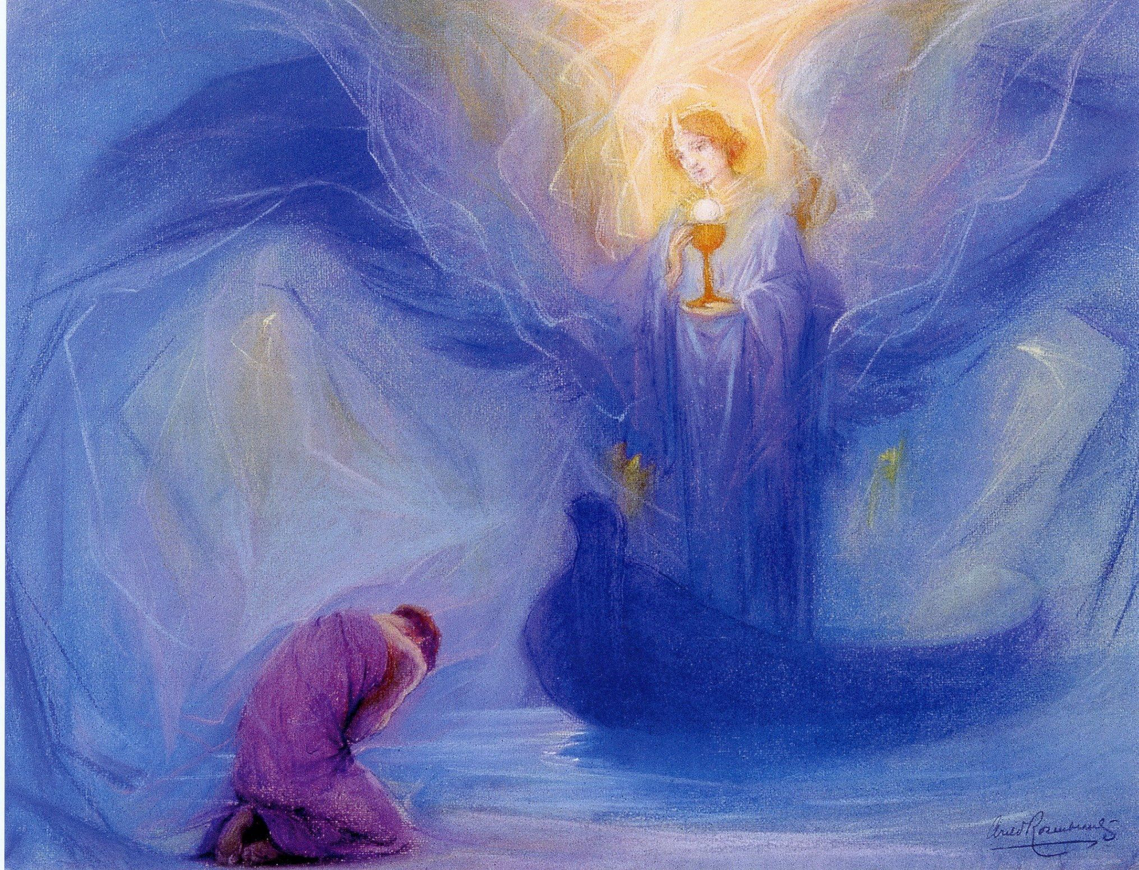
Arild Rozenkrantz, Angel

Resources
1979 edition of the BCP
http://justus.anglican.org/resources/bcp/bcp.htm
Cynthia Bourgeault, 2008,The Wisdom of Jesus. Transforming Heart and Mind – A New Perspective on Christ and His Message, Shambala.

Prepared with reverence by Maria L. de Ris

