## March 30th: Worship the Lord Your God

## The Will to Power

9… and he said to him, "All these I will give you, if you will fall down and worship me."

10 Jesus said to him, "Away with you, Satan! for **it is written**, "*Worship the Lord your God, and serve only him.'* " [Matt 4:9-10]

[Satan, from Hebrew, opponent, adversary.]

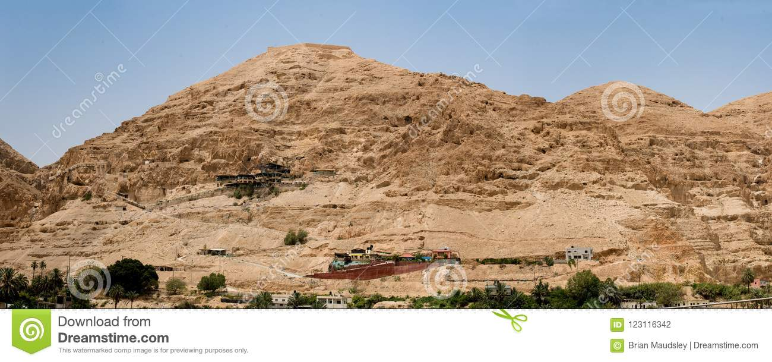

### Three aspects of the final temptation:

1. The symbolism and references to mountains in the Bible.
2. Why Jesus always responded, “It is written” (once in Luke “it is said”)?
3. The results of the three temptations

### The symbolism and references to mountains in the Bible.

Matthew mentions that the Tempter took Jesus to “a very high mountain” while Luke says that the devil led Jesus “up and showed him in an instant […]”. We can thus presume that both writers mean that Jesus was taken to a highly elevated place to be tempted by the splendor of the world.

Mountains in many sacred traditions were seen as a meeting place of heaven and earth (or pillar upholding the sky), as an abode of gods, places of oracles, or places of divine revelation. This was the case with Mount Olympus – the seat of the Greek Gods, Meru mountain in India - the home of the god Shiva and Parvati, mount Fuji, in Japan - the incarnation of the earth spirit itself.

There are many sacred mountains mentioned in the Bible. For instance, on mount Sinai Yahweh revealed his covenant with the Jewish people and Moses received the stone tablets with the ten commandments. Mount Carmel is associated with the prophet Elijah where he might have lived and where he challenged the prophets of Baal. On Mount Tabor Jesus’ disciples witnessed His Transfiguration, Mount of Temptations where Jesus was tempted, on Mount of Olives Jesus Christ prayed before his crucifixion and ascended to heaven from there 40 days after His resurrection.

The world seen from the mountain top dazzles us with its vast magnificence therefore mountains often symbolize our desires, dreams, and ambitions – which can turn out to be either positive or negative.



**Questions for reflection**

What fills us with empowerment? Power over others? Material wealth? Fame? Search for knowledge?

When and under what circumstance can we easily create illusions about our importance. What helps us to free ourselves from that illusion?

What can bedazzle us? Can our fascination of tech gadgets let them possess us? Do you feel than technology overpowers you? How quickly do you respond to pings of text messages, e-mails, notifications on social media, etc.?

Whom do we submit to? How do we train the development of fortitude and presence of mind? Is self-reflection necessary for us to be objective and in full command of our desires?

How can we discern that we act from ‘higher self’ and not from our egoic desires or wishes? Is solitude an asset in that discernment?

When do we feel humility and what effect can humility have on us?

Whom do we worship in our lives? How can we be certain that we indeed “worship the Lord your God” and not other idols? What forms of worship are most meaningful for you? What evokes in us the feeling of devotion?

How do we seek the inspiration of the spirit in all people and things?

### Why Jesus always responded, “It is written” (or once in Luke “it is said”)?

To rebuke the Tempter’s provocations Jesus offered explanations which, as both Evangelists note in each of the three instances, start with: "**It is written**, "*One does not live by bread alone* …; “**it is written**, “Do not put the Lord your *God to the test*.' "; for **it is written**, "*Worship the Lord your God, and serve only him.'* ". Only in one case did the Tempter used the expression “for it is written” when he tried to convince Jesus to cast himself down from the pinnacle of the Jerusalem temple: for **it is written**, "*He will command his angels concerning you,*'.

The phrase “it is written” in this context refers to the specific books of the Hebrew Bible which was the authoritative source for Jesus of Nazareth and the Tempter. Symbolically and metaphorically, it connects past with presence, or expressing it with other words, the path of the development of human consciousness marked by rules, teachings, moral impulses, and institutions developed over the time. This path guides and shapes our decisions. We also witness that rules and norms governing our conduct change over time.

**Questions for reflection**

What religious and secular sources of moral principles that guide us are important for us?

Do we listen to the inner voice in us? How difficult it is to discern it?

When do we act on our own without reliance to authority? What limits do we put ourselves to act solely on our own judgment?

How do our ethical values change? Do we easily adapt to the changes?

What is public opinion? How do we form our opinions and how do we present them?

How can we develop moral imagination?

### The results of the third temptations

1. The meaning of the statement **“angels waited on him”.**
2. What does the last verse in the Luke Gospel mean: **“when the devil had finished every test, he departed from him until an opportune time.”**
3. Why the Tempter used the expression **“if you are the Son of God”** for the first two temptations, but not for the third one in Matthew Gospel/ the second in Luke?

Mark and Matthew’s Gospels ended their description of the temptations with the comment: Then the devil left him, and suddenly angels came and waited on him. [Matt], “and the angels waited on him. [Mar 1:13]. Luke doesn’t mention anything about angels, instead gives somewhat cryptographic comment: “when the devil had finished every test, he departed from him until an opportune time.” We can thus infer that the angels and other spiritual beings were “on standby” when Jesus Christ was tested by the Tempter. Their absence allowed Jesus to make His own discernment, uninfluenced by others.

The Tempter refers to Jesus as “if you are the Son of God” in two of the temptations – turning stones into bread and plunging from the pinnacle of the Temple (Matt: If you are the Son of God, command these stones to become loaves of bread."; "If you are the Son of God, throw yourself down; Luke: "If you are the Son of God, command this stone to become a loaf of bread."; "If you are the Son of God, throw yourself down from here,…”)

**Questions for reflection**

What significance has for us the fact that the angels and other spiritual beings did not influence Jesus Christ’s responses to the Tempter or try to help him? Do we feel “lonely”, “empowered”, or “abandoned” when we have to make our own decisions and not see anybody to help us?

Do we recognize that Jesus Christ paved or showed us the way how to respond to adversarial forces? Do we recognize that the temptations of Jesus Christ have a universally human character?

Acknowledging that we are interdependent on each other – we rely on so many groups and individuals around us – when do we feel required to act alone and make our own choices? How do we instill independence in children?

When could we act with courage and fearlessness? What inspires us to act?

What is lurking behind Luke’s comment: “when the devil had finished every test, he departed from him until an opportune time.” When did that moment occurred? When was the devil finally defeated by Jesus Christ?

Why at the temptation on the mountain the Tempter did not refer to Jesus Christ as “the Son of God”? Why did the Tempter deliberately “downgraded” Jesus Christ? Did the Tempter himself have illusions about the Christ?

Why the victory over the three temptations was not sufficient for Jesus Christ? Why did the crucifixion have to occur? In which of Christ’s actions or acts did His love for humankind manifested in its strongest way?

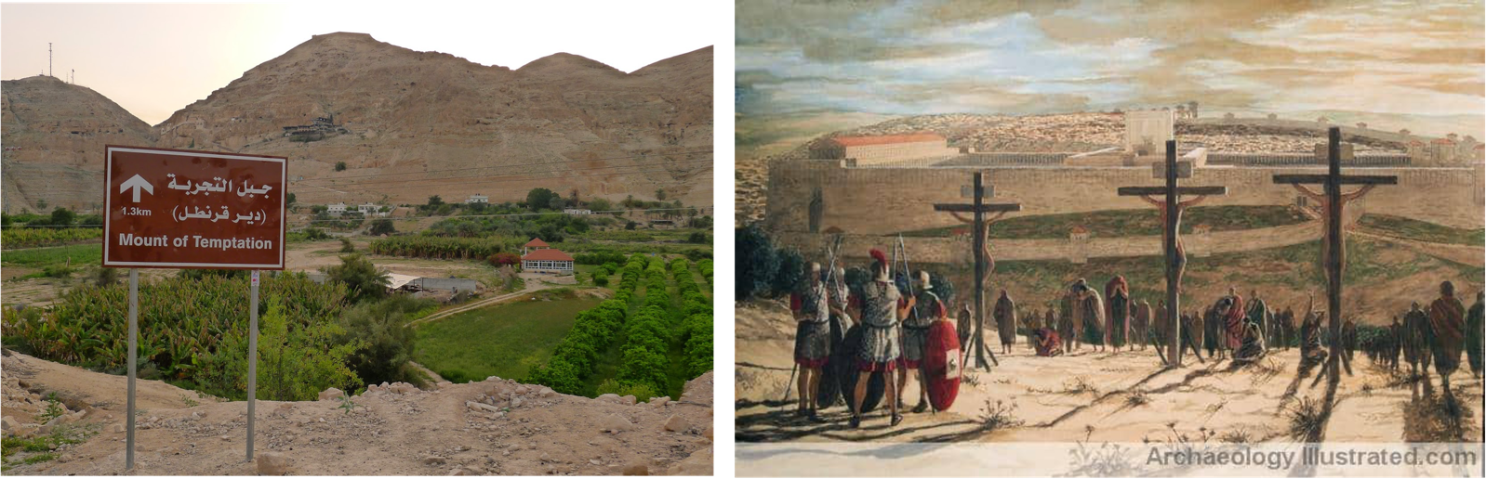

[Prepared with reverence and humility by Maria L. de Ris]