Washing of the Feet – and Act of Humility and Gratitude
[John 13:1-15]
Two timeframes – two divine manifestations and acts

Moses who lived around 14th/13th century BCE had his first encounter with the angel of Yahweh, the God of Abraham, Isaac, and Jacob, in an extraordinary phenomenon. While watching his father-in-law’s sheep he noticed a blazing bush not being consumed by fire. The angel of the Lord asked Moses to stay at a distance and take off his sandals because the ground on which he was standing was holy. [The scene is described in Exodus 3:1-17]

Another divinity, Jesus Christ, both human and divine, at the end of His three-year long mission, assembled his twelve core disciples for a Passover meal in Jerusalem. After the meal, He scooped down in front of each disciple, and with humility and with gratitude for their service, washed their feet.

This deed is presented only in John’s Gospel (written around 100 AD, many years after the first Gospel was written) – no other Gospel mentions it, even though all Gospels present a detailed description of the Passover meal and of Christ’s passion that followed it.

Foot washing was an established custom in Judaism. The first mention of foot washing is presented in the Book of Genesis when Abraham offered water to the three visitors who came to him. All priests were required to wash their feet and hands before entering the holy place of the tabernacle. This habit, a sign of hygiene, hospitality, and purification, was well-established not only in Jewish communities, but elsewhere. It was very common in majority of wealthy households that slaves washed the feet of guests.

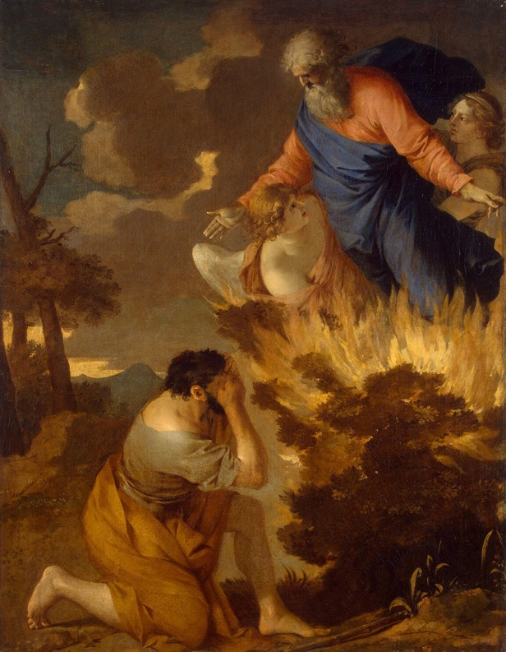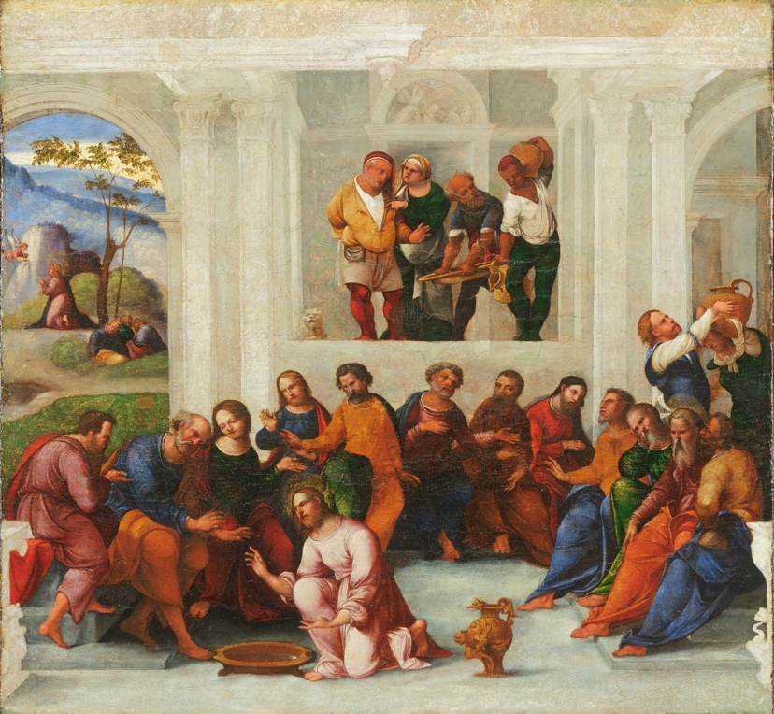
Sébastien Bourdon, Burning Bush, XVII C; Lodovico Mazzolino Christ Washing the Feet of the Disciples,
Wikipedia 1527;
Questions for reflection
Is there a greater contrast representing the relationship of the Divine to the human beings than Moses’ vision of the angel of Yahweh and Jesus Christ’s act of washing of the feet?
Imagine that you were one of the disciples and Jesus Christ, your most revered Rabbi and Messiah, was getting ready to wash your feet – what would you feel? Would you respond like Peter?
Why do you think other Gospels didn’t include the description of this act?
What message is Jesus Christ giving us by washing the feet of his disciples?
What can make us humble?
What other acts of “stooping” – with the literal and figurative meaning – have you encountered? I have a neighbor, an elderly woman, whom I see in summertime walking nearby picking up trash scattered around. Would you say that she is an example of “stooping service”?

Purification – with water, thinking, and forgiveness

Water is used in practically all religions (Judaism, Christianity, Buddhism, Islam, Shinto, Daoism, etc.) in blessing, banishing or purifying rituals because of its perceived holiness (water can appear in three different states: solid, liquid, and gaseous). The ancient Hebrews’ passage to freedom went through the waters of the Red Sea. Water is one of the substances used in the sacrament of baptism in Christian ritual.

Daoism offers simple and beautiful descriptions of water’s properties:

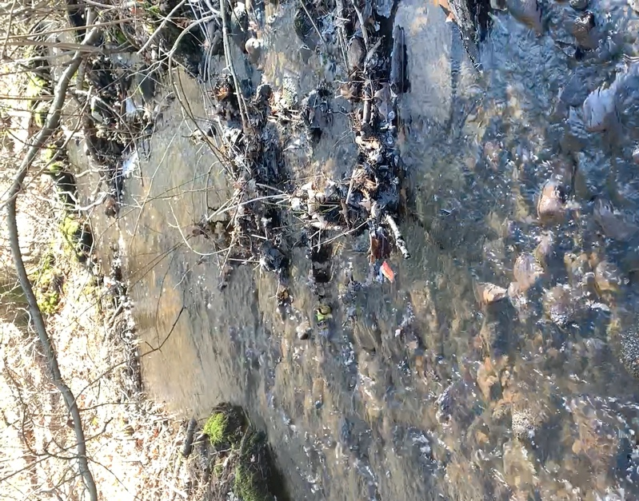
Great good is like water.
Water is good at nourishing all things.
It also strives to settle in places people detest.
[…]
Nothing in the world is softer and weaker than water.
Yet nothing can surpass it
for subduing the hard and the strong.
Nothing can replace it.
Everyone knows that the soft overcomes the hard,
and the weak overcomes the strong,
yet no one can put it into practice.

[老子,道德经, Lao Zi, Dao De Jing, 8, 78]
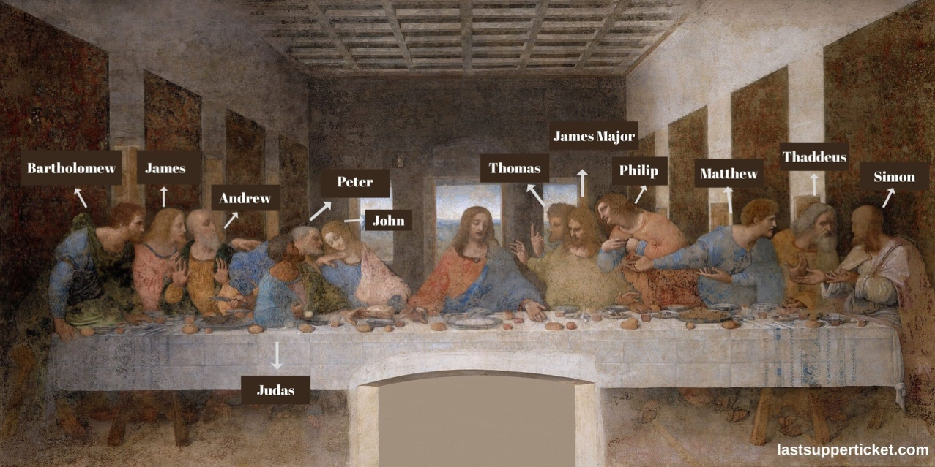
Leonardo da Vinci, The Last Supper

When Peter objected to let Jesus Christ wash his feet, the Christ responded: "One who has bathed does not need to wash, except for the feet, but is entirely clean. And you are clean, though not all of you." [John 13:10] The Greek word used in this text is καθαρός katharos and it means both clean and pure. It serves as the base of the English word “catharsis” meaning purification – cleansing, for instance a relief from negative or repressed emotions, or a form of spiritual renewal. Thus, we can infer that the Christ by saying “you are clean” didn’t just mean physical cleanliness of the disciples but pointed out to their spiritual purification performed symbolically by water, but in effect by his own sacrifice He was ready to make. The Christ’s death on the cross made the apostles, and all affected by the sacrifices, holy – this is the literal meaning of the word “sacrifice” = to make holy (sacer+faciō).

Questions for reflection
What effect does water have on you? When do you feel cleaned?
How do you work with negative emotions, such as anger, hate, frustration, etc.? What is your best method to transform them?
Did you feel purified after a confession/ sacramental instruction/ spiritual direction with a minister?
How do you keep your conscience clean?
Could a loving gesture have a purifying effect? Could forgiveness have purifying effect on the perpetrators?

Interdependence – the higher depend on the lower and are responsible for the lower

Everything in nature is interdependent – the higher domains are the product of the lower. Thus, plants depend on the minerals, they take nutrients from the ground; animals depend on plants; human beings depend on the mineral world, animals, and plants.

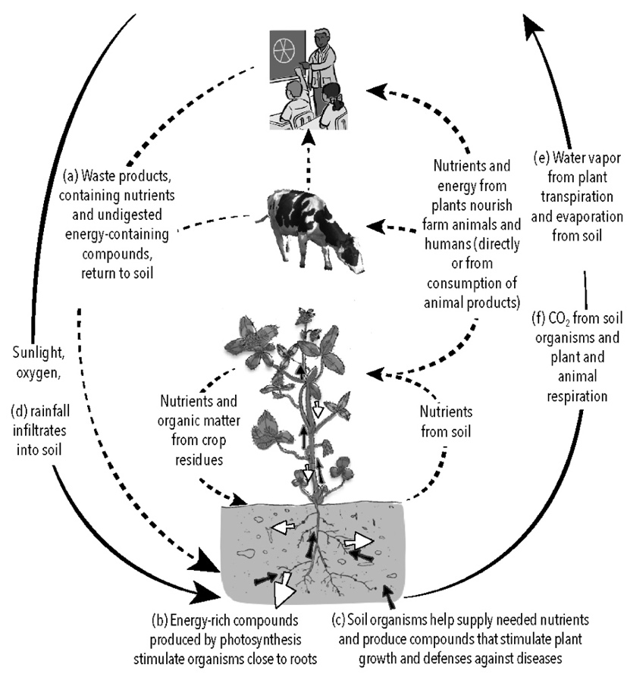
Matthew 20: 25-28

25 "You know that the rulers of the Gentiles lord it over them, and their great ones are tyrants over them.
26 It will not be so among you; but whoever wishes to be great among you must be your servant,
27 and whoever wishes to be first among you must be your slave;
28 just as the Son of Man came not to be served but to serve, and to give his life a ransom for many."

John 13:16
Very truly, I tell you, servants are not greater than their master, nor are messengers greater than the one who sent them.
Soil-plant-animal-atmosphere metabolic interactions

Questions for reflection
Did you ever “lord over others”? What would be the difference between “lording” over others and exerting “authority” over others?
When it is useful to follow hierarchies, social/ professional ranks and when it is enlightening to abandon them?
How do you express your gratitude to nature – to animals and pants?
What examples of individuals who followed the rule “the first among you must be your slave” do you know?

Sources
Valentin Tomberg, Christ and Sophia. Anthroposophic Meditations on the Old, New Testament & Apocalypse, (Great Barrington, MA: SteinerBooks, 2006).

[Prepared with reverence by Maria L. de Ris]

